
JAARS Center, Box 248, Waxhaw, NC 28173, USA

Speech Analyzer
for Microsoft® Windows™

System Documentation

Revision History
08/15/96 | V1.0 Initial version | U. Ruchti
01/24/97 | V1.1 Object overview update | U. Ruchti
10/24/97 | V2.0 Beta 0.97 documentation | U. Ruchti
Contents

1. Introduction
2. Architecture
2.1 Object Overview
2.1.1 Application and Mainframe
2.1.2 Document
2.1.3 View
2.1.4 Workbench
2.1.5 Character Table
2.2 Use of MFC
2.3 External Classes
3. How and Why
3.1 Application
3.2 Error handling
3.3 Load/Create and Save Wave Documents
3.4 Graphs
3.5 Segments
3.6 Status Bar
3.7 Edit Wave Files
3.8 Undo/Redo
3.9 Player/Recorder
3.10 Processing
3.11 Graph Overlay
3.12 Settings
3.13 Printing
3.14 Workbench
3.15 Character Table
3.16 Miscellaneous
4. Suggestions
4.1 Processing
4.2 Segments
4.3 Workbench
4.4 Undo/Redo for Wave Editing
4.5 Miscellaneous
4.6 32 Bit Version
4.7 Porting to the Macintosh®
5. Appendix
5.1 RIFF Structure Version 7.0
5.2 Database Calling Procedure

Introduction
This system documentation has unfortunately not been written during the process of designing and programming Speech Analyzer (SA), but close to the end of the work (Version Beta 0.97 from August 1997). Since several programmers worked together on the program, the coding style is different in different parts of the program. Even naming conventions are different and not everybody used the hungarian notation or at least in a different manner. The big part of SA has been written by the author of this document (me) and I tried to be consistent and to comment the code as much as possible. But in the last couple of weeks, when time was precious, I lost control over the code of the other programmers and there are parts with very little comments, which I don’t fully understand. Some code is also quite messy and close to C-style. SAs history shows a lot of sometimes big architectural changes, which caused a lot of bugs and especially a lot of not up to date comments.
This documentation expects, that the reader knows C++, how to program for Microsoft® Windows™ and the Microsoft® Foundation Classes (Version 1.52).
Class names are printed in bold throughout the document, function names are bold italic and variable and constant names are italic only.

History
Model for SA was WinCECIL, a program from SIL (for Microsoft® Windows™ 3.x), which was well established and doing a good job for the translators. But it was written in C and the user interface was very special. There was no documentation and the code was not well commented. Then there was a first version of SA with just some basic functions from WinCECIL written in C++ but with a very poor design (more like C) and a quite messy code.
So we started SA from scratch again with a well designed user interface. After having the interface working, we started filling in the code behind. Unfortunately the SA functions became more and more and also more complex than we had in mind, when we designed the user interface and the system architecture. This facts made me change the architecture in several parts of the program. A good example are the annotation windows. At the time of the object design, there was one annotation window planned. After having the code working for the window, there was a second one necessary. I did not write a base class for the two at this point, because it was easier just to copy the class of the first one and modify it. The segmenting part also got two classes. Then later there was a third one necessary. Now I needed to write a base class for the window and the segmenting and change the whole addressing and calling architecture throughout the program. Now we have five annotation windows!
The program and its behavior was growing and changing with its size. Then close to the dead line for version 1.0 we encountered several design problems which would have caused a lot of changes to fix them properly. But we did not have enough time to do it and we built in some tricky things. Some of them are in the printing routines.
Another restriction was the fact, that future SA version should run on 16 and 32 bit systems and also on the Macintosh, but the first version had to be a 16 bit version. Therefore we sometimes had to avoid easy 16 bit only solutions and do it the hard way. On the other hand, we often were restricted in the use of newer MFCs and had to write 16 bit classes that existed already in 32 bit versions.
The last important point, which affected my programming style and the use of MFC (Microsoft® Foundation Classes) was the fact, that this was my first work with MFC and I learned the capabilities by using them. The whole Microsoft® Visual C++™ environment was new for me and I missed the Borland® environment.
I worked on Windows95™ and some things may not look very good on older Windows™ versions. But they will still run.
In the early stages of SA there was a experienced programmer going trough the code and modifying it to make it compile for 32 bit and for the Macintosh. The code compiled and worked fine for 32 bit. Parts of it worked on the Macintosh®, but for instance the mini caption windows don’t work there. We tried to write the code compatible for the 32 bit and the Macintosh® cross compiler, but we never had the time to test it.

Design
The user interface had to be conform to Windows™ but some things are conform to WinCECIL. One of the most important design questions was the one of how to display all the graphs in the views. There were three possible ways. First, the graphs could have a fixed size and position in the views (like in WinCECIL). Then second, we could use splitter windows or third we could create our own graph windows (child windows in the views). The first way is not flexible and easy to use enough, the second would not allow different window classes in the splitter windows and limit the number of graphs to 1, 2 or 4. In the beginning, the third way, which one we chose, meant more work, but it was the right way. Unfortunately was the key peace of code (mini caption window) written by another programmer, who did not test very well and not finish the code. Since then several people including me worked on it and tried to fix bugs and the code is messy now, but it works.
How I said before, the first design was just a small part of what it is now, because SA grew so much. We tried to use MFC as much as possible and to be as modular as possible and use the full power of OOP.

Tools
We worked with Microsoft® Visual C++™ Version 1.52 (16 bit) on Windows95™ and Windows for Workgroups™ 3.11. We used Microsoft® SourceSafe™ on a PC-server to archive the code. On the same server we had the Microsoft® Developer Network™ running.
This documentation has been created with Microsoft® Word for Windows95™ version 7.0. The drawings are made with Micrografx® Designer for Windows95™ version 6.0a.

Architecture
We use the general MFC document-view architecture for SA. SA uses a multi document interface with two document templates (wave files and workbench files). We don’t use archive and serialize functions in the document (only for undo/redo functions), because of the very special format of the wave files. The wave file views contain the special graph windows.
Because SA needs to be able to run on the Macintosh® (cross compiled) we could not use MFCs standard ‘ini’ file implementation. Another specialty is SAs batch mode. If called from a database program, SA starts up in batch mode (does not exit).
The workbench view is a form view and behaves not exactly like a normal view, there are some overrides for this part.
We used the right mouse context sensitive menus, like they are used in Windows95®. They are not yet implemented in the workbench.
For the dialogs we used different methods to initialize and get back dialog data. The most used method is to let the dialog class gather the necessary information from the parents, views, documents and whatever and store it internally. Then we used MFCs data exchange possibilities to keep the data up to date. At the end, the dialog class would distribute changed data by itself. The other way is, to let the dialog caller initialize the dialogs internal data members and read them back after finishing (used for example for the options dialog). This second method is nice, if the dialog only needs data from the caller and is used just once. This is often not the case. I prefer the first method, because the dialog data can be private or protected, the encapsulation is better and the calling procedure is much easier.
Every setting, which can be changed, like fonts, colors, sizes etc. should not be “hardwired” in the code itself but taken from either SAs global definitions, or from the mainframe (colors, fonts etc.) or from the Windows® system settings. This makes changes much easier and makes SA adapt better to different Windows® settings and different hardware.
All the global definitions for the program are kept in the file ‘appdefs.h’.

Object Overview
I don’t explain single classes in this overview. Use it as a reference to find classes (and the files with the code) and to see how the are connected together.

Legend
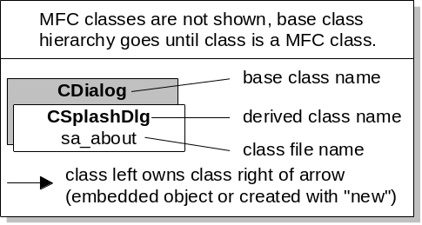
This overview includes most of the created classes but not MFC classes. The connections show, that either a class uses another class as an embedded object or it creates one with the new operator. There are some special objects like the tool tips class, which derives from the MFC toolbar class and is used from the MFC framework and not shown in the overview. There is not always every connection shown, but the needed and important ones.

Application and Mainframe

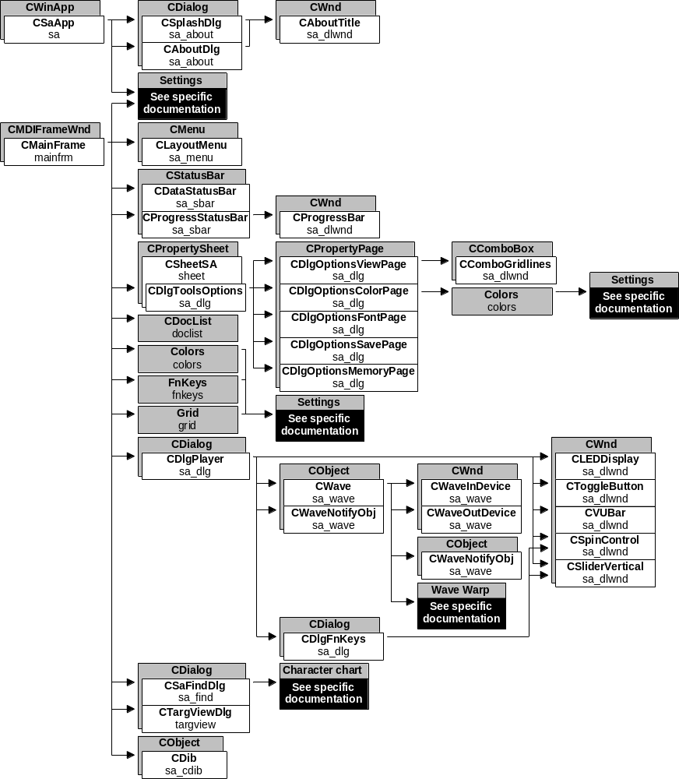

Document

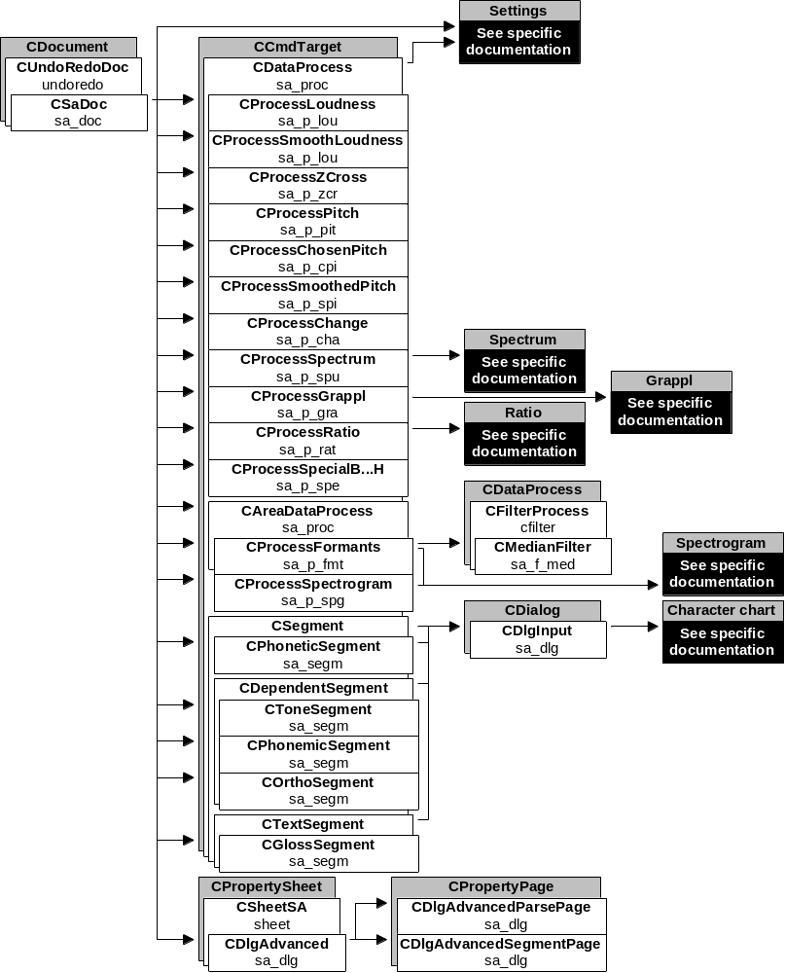

View

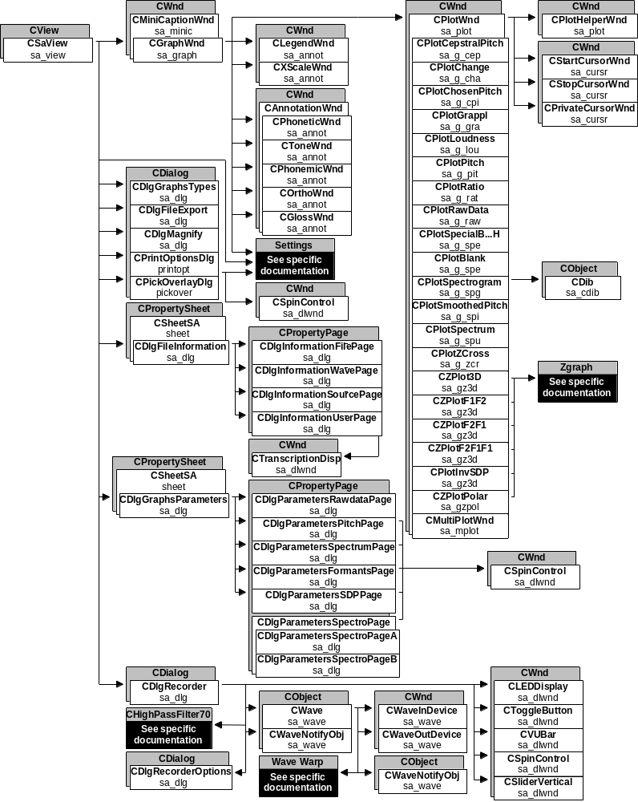

Workbench

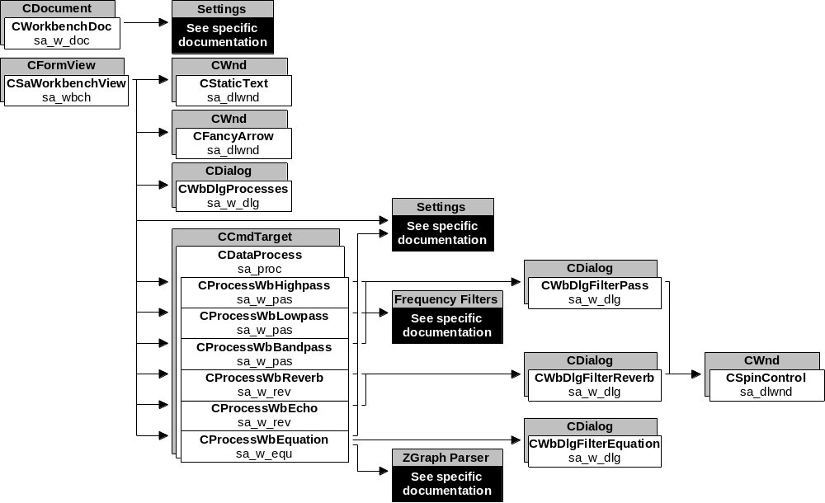

Character Table

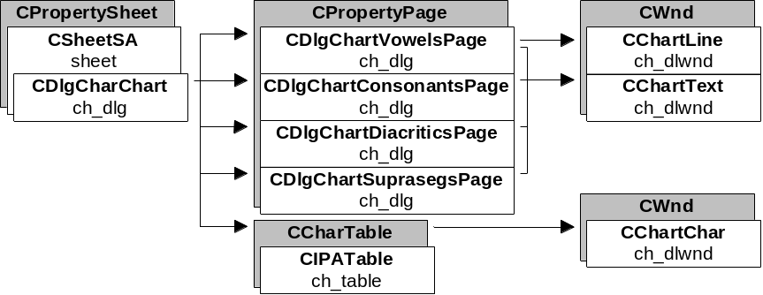

Use of MFC
We tried to use MFC classes as much as possible. Almost all our classes are derived from MFC classes. There were some bug fixes necessary like the one for the CPropertySheet class, but in general MFC is a good class library. Unfortunately we were forced to write a 16 bit application and therefore we could not use newer MFCs. Classes for progress bars, spin controls and sliders etc. exist in 32 bit versions, but we had to write our own ones.

External Classes
SA uses some external code and I expect, that this code has his own documentation:
- Grappl: C-code (SIL) with pitch calculation from wave data, used for auto pitch graph process
- Settings: C++ code (SIL) from Shoebox version 3.0 used to save and restore program settings
- Spectrogram: C++ code (SIL) with spectrogram, spectrum and formants calculations used for several graph processes
- Tooltips: C++ code used to implement tool tips
- WaveWarp: C-code (SIL) to slow down or speed up speech data without changing pitch. Used for player
- ZGraph: C++ code package to display all kinds of graphs. Used to display formant and SDP graphs and for the equation filter.

Be careful with these pieces of code, they may be modified from its original state (ZGraph is!) to fit SA or for bug fix purposes.

How and Why

Application
The application class CSaApp called by the framework initializes the application. The function InitInstance gets called first and there we register to two document templates for the wave files and for the workbench. Then we check for batch mode (CheckForBatchMode) by reading the command line arguments.

Batch Mode
Batch mode means, that a database program called SA and delivered a path to a list file in the command line, where the paths to the files to open (and in future may be process) are listed. In batch mode SA does not allow to open files (only create new ones), because the calling database told SA, which files to open. In batch mode SA does not exit, but hide itself and send a message to the database program (which hid itself after calling SA) to wake up and read back the files listed in the list file. Be careful to catch all the exit paths to prevent SA from exiting (close button, menus). SA modifies the list file every time, the user closes a file or creates a new one.

Starting up
Then we check, if a database program is running (IsSMrunning from CMainFrame), which called SA. If yes, but no batch mode has been detected, we don’t start SA because this would be an illegal state. Right now IsSMrunning checks for a program caption name and the name is stored as a constant in SM_CAPTION but this should be changed later for a more general use of databases. The database name should be passed in the command line for example by the calling database program. After creating the splash window (not in batch mode, because SA can be in memory already and come up very quickly, and the user wants to switch back and forth between SA and the calling database program, the splash window would be annoying) ExamineCmdLine examines the command line. In batch mode this function opens the files needed, positions the mainframe window, sets the start and stop cursors and zooms into the graphs. In record batch mode it also starts the recorder. Then we read the application settings, but only a part of them in batch mode, because we don’t open the same files and graphs as in the last standalone session.

Error handling
I’m afraid my error handling design is bad and not very sophisticated. One reason is, that I did not know MFCs possibilities in the beginning and I did not take the time to change everything after I knew it, because it was a lot. An other one is, that different program parts from different programmers used all kinds of error handling and it seemed too hard to me to put everything together into one system. My SA part uses the TRY and CATCH mechanism from MFC, but never nested in different levels (I also do not throw exceptions by myself) and distributed all over the program. The idea is only, to let the user always see that an error happened, but not always to explain the reason or at least not too detailed (the message should be understandable). There should be only one, maximum two messages per event.
It is not always easy to display an error message. For example in modeless dialogs (like player) they would not come up on the screen until the dialog was closed or the would show up more than once. But CSaApp provides a simple error message system, which guarantees, that the message will show up on the screen and just once. MFC helps to get a pointer to the application from everywhere and then just call ErrorMessage with the message ID and up to two strings. This function will store the message in an message array. As soon as CSaApps OnIdle function becomes called, it displays the oldest message and deletes it from the array. If you are not sure, that CSaApps OnIdle will be called, you can call CSaApps DisplayErrorMessage directly.

Load/Create and Save Wave Documents
When CSaDoc loads a wave file (OnOpenDocument), it opens the file, searches through it to find the right RIFF chunks and makes a complete work copy of the data:

RIFF header data (format parameters) and wave parameters (sa chunk, utt chunk etc.) become loaded into CSaDoc member data.
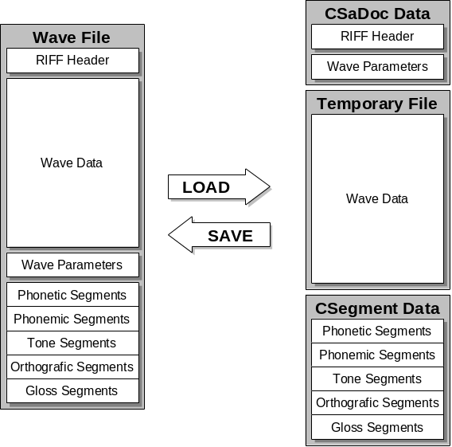
The whole wave data chunk becomes copied into a temporary file (owned by CSaDoc) in the Windows™ temporary directory (CopyWaveToTemp).
The whole segmenting information (character strings, offsets and durations) for all segments becomes loaded into the different segment classes member data.
SA works only with the copy of the wave file data. The wave file stays closed until the user saves the changes (OnSaveDocument). Then the three data parts of the copy will be copied into the wave file and overwrite the old data.
After having saved data into a wave file, SA sets the file properties to read only to prevent other programs from editing and destroying the segmenting and other SA specific data (SaveModified).
CSaDoc uses the standard framework calls from MFC but we had to override some functions also to display extended information in the views caption (and to remove it before saving a file, because MFC reads the caption to get the file name).
SA works with a wave copy, because we need to be able to cancel changes made by editing wave data. This is only possible, if we keep the original wave data unchanged, until the user saves the changes. OnOpenDocument is able to read a wave file without any SA specific wave chunks, therefore it also opens files with old RIFF versions. If it doesn’t find a RIFF chunk, it just looks for the next one and goes on with the default parameters. The defaults are set in DeleteContents, which is called by the framework, every time a document object is created or deleted. OnSaveDocument is more complicated, because it also deals with newly created files. It always assumes, that the file to save exists and contains the RIFF header with the format chunk and the data chunk. It does not write the format chunk! This chunk has to be written correctly by creating the file (and then never changes). But it overwrites the data chunk with the contents of the temporary wave copy and it creates (or overwrites) all the other chunks. The save function won’t do anything, if the file is owned by a database program (flag m_bDatabase set). Now, if the file to save does not exist already, this means that the string m_szTempWave contains a file path (see “creating a wave file”) it first has to be renamed (or copied if the source and target drives are different) into the file, that the user chose with the file save as dialog (called by the MFC framework), and then saved normally.

Creating a Wave File
This action seems to be too complicated and it probably is. Unfortunately the whole file creation code is located in the recorder dialog class. This is because in earlier days, only the recorder could create a new wave file. This is no longer true but because of lack of time I did not rewrite or relocate the code. See “player/recorder” to learn, how the recorder creates a new wave file. We will have a look at PasteClipboardToNewFile (member of CSaApp), which creates a new wave file with wave data from the clipboard. First it creates a new document and view (wave template). The flag m_bNewDocument needs to be set, because this prevents the view to load the default graph settings (in OnInitialUpdate of CSaView). The newly created view is only allowed to create the raw data graph, because there is no wave data yet to be processed for the other graphs. This is exactly the same procedure so far as for the start of the recorder (OnFileRecord of CSaApp). But then, instead of creating and calling the recorder dialog, we just construct the recorder. Then we use its functions to create and open a new temporary wave file (CreateTempFile) in the Windows™ temporary directory. At this point, the wave file has the RIFF header, the format chunk and the data chunk created, but the format chunks data has default values and the data chunk is empty. The file pointer points to the first byte of the data chunk. Now we copy the wave data from the clipboard into this file (be sure to lock and unlock the allocated clipboard memory). The clipboard also contains the format parameters (see “edit wave files”), and we need to set the newly created documents format parameters, because the recorder code will use this parameters to write the format chunk. This happens by calling Apply from the recorder, which fills in the format parameters, closes the file and sets up the documents sa parameters and the wave chunk size, ready to save into the sa chunk later. It also sets the documents m_szTempWave string to the file path of the temporary file. Be sure to call the recorders functions ClearFileName (shows the recorder, that the file has been overtaken from the document) and CleanUp (frees the recorder buffer) before deleting the recorder.

Data Buffering
OnOpenDocument allocates memory for the wave data buffer (the destructor frees it). This buffer always contains the last used block of wave data. It is filled up for the first time in OnOpenDocument with the first block of data. The buffer speeds up SAs operation, because it delivers often used data (screen redrawing etc.) much faster than a read access in the temporary wave file would. The buffer will be reloaded from the temporary wave file, whenever SA requests data, which is not in the buffer already. The buffer size is changeable (tools options memory), but the document objects have to be deleted and reconstructed if the size changes.
Now there is a very special thing about, how to get data from the wave file. The source file can be redirected to a workbench processed temporary file. The variable m_nWbProcess contains a number, which indicates the workbench process number, whichs temporary file will deliver the wave data. If this number is 0, the data comes from the normal temporary wave file. There are helper functions in the CSaDoc class, to get wave data. The most used one is GetWaveData, which exists in two forms. This functions redirects its source according to m_nWbProcess. You can get one single byte of data, you can get a pointer to the data buffer after having loaded a whole data block or you can force the data buffer to contain a block out of the normal block order and you determine, which byte will be the first one in the block. GetWaveData always checks, if the requested data already exists in the data buffer and only reloads from the file if necessary. Be aware, that the whole document class works with byte addressing and not with samples! The other function is called GetUnprocessedWaveData. It is exactly the same like the block form of GetWaveData (actually GetWaveData calls GetUnprocessedWaveData), but it does not redirect and gets data always from the normal temporary wave file. This function is used from the workbench processes, to get the original wave data for the calculations. The same system is implemented to get the size of the wave data. GetDataSize redirects but GetUnprocessedDataSize does not.
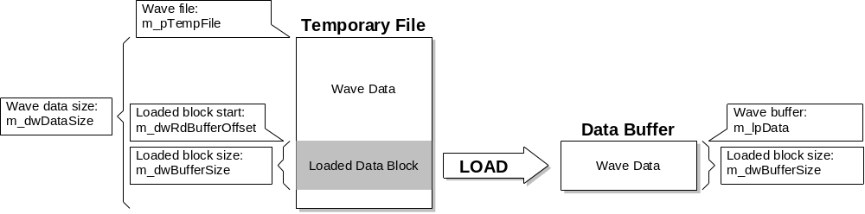

Graphs
The graph objects are owned and created by the view. The view knows the type of graphs to create from the graph types dialog (CDlgGraphsTypes) or from the right mouse menu (only graph type change possible) or from the settings after startup. The view keeps an array of pointers to the graph objects (m_apGraphs) and an array of graph IDs (m_anGraphID) to be able to identify the graph type. There are up to MAX_GRAPHS_NUMBER, but at least one graph possible. A view without a graph is not allowed. If the last graph in the view closes, the view closes too. For this reason, every closing graph sends the message WM_USER_GRAPH_DESTROYED (from the mini caption window classes message handler OnSysCommand) to its parent view. The views message handler OnGraphDestroyed keeps track of the graph arrays, and deletes the closed graph out of them. It shifts the other objects to fill empty slots in the arrays. If there is no other graph object, it sends the message ID_FILE_CLOSE to itself, which closes the view and the document.
Empty slots in the views graph arrays are determined by a NULL pointer and a graph ID of 0. The view keeps the order of the graphs as created first. It retiles the graph windows according to the given graph layout (stored in m_nLayout). The view owns flags for most of the graph settings (windows on/off etc.) and changes them in all the graphs together. The graphs themselves can change their settings individually by using the right mouse menus. The view keeps track about which graph has focus. It stores a pointer to the graph with focus (m_pFocusedGraph) and its ID (m_nFocusedID). The view also knows, which portion of the wave data is to draw in the graphs and how much to zoom in or out (m_fZoom) and it does the scrolling. For scrolling of the graphs it calls graph functions. The view also keeps the position of the start and the stop cursor (not for the private cursor, because this is a cursor private to the graph, not synchronized with the other graphs). Because all this functions are synchronized between the graphs, the view needs to be informed about every change in the graphs to be able to inform all the other graphs. All the data positions are in bytes, not samples.
The graph (or mini caption) windows own a number of child windows. The graph creates the five annotation windows (array m_apAnnWnd with ANNOT_WND_NUMBER windows), the legend (m_pLegend) and the x-scale window (m_pXScale) and the plot window (m_pPlot and ID in m_nPlotID). Every one of them except the plot can be visible or not (chosen by the user). The legend and the x-scale can be setup by their member functions SetScale. If they are invisible, they are still there but sized to zero size. The order of the annotation windows is given by Annotations (enum) and could change, if the phonetic window stays in position zero. But there are other things, keeping the same order (colors, fonts etc.) and it is better not to change it.
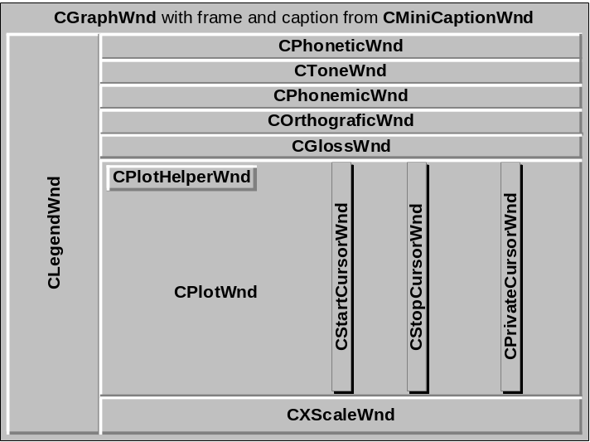
The plot owns again four child windows. The helper window (m_HelperWnd), which is used to display special user information (like “aliased data” in the spectrogram plot) and is normally not visible. You can set the helper window mode by calling its member function SetMode. The plot has a standard drawing function, which can be used. The functions PlotPrePaint and PlotPaintFinish must be called before and after the drawing in the plot. They draw the grid respectively the boundaries.

Cursor Windows
The plot window owns the three cursor windows. They are transparent and the plot changes their width. In normal state, they have the width of twice CURSOR_WINDOW_HALFWIDTH, but while being moved, their width is just one pixel. This is, because we want to be able to grab them easily, if the mouse comes close to them. If they have the large width with the cursor line drawn in the middle, and the mouse cursor moves over them, the cursor changes to a hand and all the mouse messages go to the cursor window. While moving, we don’t want to redraw such a big portion of the underlying plot window and we change it to the small width. This means all kinds of difficulties with moving and scrolling cursors, especially because they draw with raster operations to change the cursor line color on different backgrounds (never draw twice on the same position, except you redraw the background (underlying plot) first). Please, be very, very careful and test carefully if you change something, which affects the cursor windows. The raster operations are a source of problems too, because they behave different on different graphic cards. I tried all possibilities on different cards and it seems to me, that the current solution brings the best result for all I tried. I use two different operations dependent on how dark the user chooses his cursor color. For dark cursors I use the operation R2_MASKPENNOT for light ones R2_MERGEPENNOT. A cursor color is dark, if the arithmetic sum of the three color parts (RGB) is higher than 380.
The normal plots show the start and the stop cursor windows, but not the private cursor window. The start and stop cursors are synchronized with the view and all the other graphs and the plot gets advice to move the cursors and their positions from the view. There are plots like spectrum, which don’t synchronize with the other plots in the view and they need an independent cursor. For these cases we have the private cursor. The plot keeps track about the cursors position by itself.

Cursor Snapping
Cursors are able to snap to the closest zero crossing in the wave data. This snapping function gives better results for data processing and editing wave files from cursor positions. The user can turn it on or off (tools, options), but it should kept turned on. Especially the spectrum process needs the snapped positions, to be accurate and it changes its process, if the cursors are not snapped. How does it work? The document has a member function called SnapCursor. It is called by the view for every cursor movement. It returns the closest possible zero crossing position inside the given limits.
There is a number of rules to follow:
- The left cursor has to be aligned at the first sample after the wave data changes sign. For example, if the wave data goes from negative to positive, the cursor should be aligned on the positive sample; from positive to negative, on the negative sample; from positive to zero, on the zero sample; and from negative to zero, on the zero sample.
- The right cursor has to be aligned in the same way as the left cursor.
- In the trivial case where the wave data never changes sign or touches zero, the cursors don’t change position (don’t snap).
- The left cursor always stays left of the right and the right always right of the left cursor.
- For selected segments, the left cursor has to snap to the zero crossing at or right of the segments start position. The right cursor has to snap to the zero crossing at or to the left of the segments end position. This behavior eliminates editing and overlapping problems with (old) not snapped segments.

Area Graphs
The standard graph object gets its data and position information from the parent view and the document. But there is a special kind of graph, which just works in an area of the whole wave data. This graph is called Area Graph and is determined by the set flag m_bAreaGraph (use SetAreaGraph to set it). Area graphs look a little different: They have the recalculate button to change and reprocess the area and they behave different (see “processing”). Area graph start and stop cursors are still synchronized with the other graphs, but they move different, because the area drawn in the graphs plot is different from the other graphs. Area graphs don’t scroll and zoom. They keep their selected area until they receive the recalculate command. This kind of graph is used for processes, which use just a small part of the whole wave data (spectrogram, formant graphs). They are not accurate and fast enough for the whole data. Area graphs allow more than one graph of the same kind in the same view (normal graphs don’t) and allow comparisons between different areas.

Spectrogram Graph
There are several special graphs, which need special code to draw like all the Z-graph plots or the raw data graph. But they are not very hard to understand and won’t be discussed in detail. But there is the spectrogram graph, which one is very special and complex. It is very different from all the other graphs, because is deals with colors and pixels and looks like a bitmap. There is a lot of work, old solutions with a lot of problems behind the current solution. The older solutions all worked with bitmaps. The spectrogram process created a bitmap, which one we put onto the screen by changing the color palette. This way was very fast, but never worked properly. The bitmap was not sizable in an proper way and therefore we had to recalculate every time the user sized a spectrogram graph. Then there were always problems with the colors on different graphic cards. The current solution now works fine, solves all the problems we had before, processes faster (because we don’t produce a bitmap anymore) but draws slower and has a limited number of 117 colors for a 256 color graphic card. We will now see why.
The spectrogram process creates an array of numbers with 235 levels (0...234). To display the full resolution, we need 233 colors (plus the black and white from the system colors). We also do the same for a black/white spectrogram with a gray scale of 233 grays. Now because the user can choose between black/white and color on the fly and he can have several spectrograms on the screen at the same time, we need the two palettes at the same time (always present). For the different graphic cards we need to create different setups. For 16 colors, we just use the present setup, because the system already uses all the colors for its purposes. For 256 colors, we create 117 grays in the lower part of the free slots and 117 colors above. For cards with higher resolution we can create the full 233 gray scale in the lower part and 233 colors above. The question is now, how we link the levels with the palette together and how we switch between black/white and color. We use a color reference system:

The palette creation is done in the CPlotSpectrogram member function CreateSpectroPalette. It checks the device capabilities of the graphic card. The palette is created just once for all the spectrogram graph (the flag to indicate an initialized spectrogram palette and the palette are static). But then we create for every spectrogram plot an array of 236 color references (Color containing COLORREF). The array contains references (index) to the palette (PALETTEINDEX). We could also load colors from the palette to the Color array. It works but if we use the palette index method, the drawing speed is significant higher. Now we can setup the Color array independent of the kind of graphic card and the number of colors we have. If we have just 16 system colors, a lot of colors in the Color array will have a reference to the same color in the palette. It is the Windows™ system, which one chooses the closest color in the palette. We can switch between gray scale and color spectrogram by just changing the references in the Color array. We don’t need to change the palette. We use the API call SetPixel to set every pixel in the plot with the right color. We pass a color reference from the Color array to SetPixel, which one then uses the right color from the palette. If the plot has been resized by the user, we don’t recalculate, but we draw the pixels larger or smaller. In case of smaller pixels (plot is smaller than at the time of calculations) we loose information, we draw some pixels over others. In the case of larger pixels, we draw the same color for several pixels.
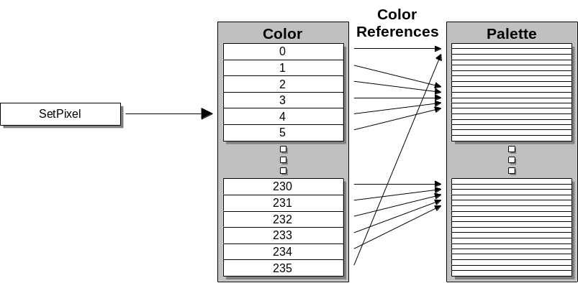

Segments
A wave file can have up to five different annotation strings (phonetic, phonemic, tone, orthographic, gloss). These strings are split up into small parts, normally one part per sound in the wave data. They contain one single character or a string with start position (called offset) and duration. These parts are called segments. The positions are stored in bytes (not samples) and are called boundaries. There are several segmenting rules:
- Every phonemic, tone, orthographic or gloss segment has its boundaries aligned to a phonetic segment. Aligned means, they are exactly the same. These segments never exist without a phonetic segment and are called dependent segments.
- Every segment contains at least one character or a string.
- Gloss segments contain only strings (empty strings are possible) and a delimiter (character) which shows, what kind of segment it is (bookmark, gloss). They are called text segments.
- The gloss segments duration does not align to the phonetic segment, but is set automatically so, that the end of the previous segment is one sample less than the start of the next segment or the end of the wave data. This rule makes sure, that the whole wave data lays within a gloss segment. Every gloss segment counts as a word. There is only one unglossed part possible, and this part is counted as a word too.
- Phonetic segments are allowed to overlap up to 50% of the duration of the neighboring segment.

Now there is a big problem with the architecture of the whole segmenting part. First, we had only the phonetic segments, then it grew and in the beginning I did not realize, that the other segment boundaries are always exactly the same as the phonetic segments (except gloss with its different duration). I also did not realize, that the way, how the segmenting information is stored in the wave files is awkward and that I should use a different system internally. When I realized this, the code was written and used throughout the whole program and the architectural change would cause a lot of work (and bugs). There was no time to do that. Now we have a quite complex segmenting system. Be very, very careful and test carefully, if you make a change in the segmenting core. Right now, dependent segments have to be created by the user, even if at the same position a phonetic segment already exists. This would not be necessary, if we had another segment architecture. It could be changed also by additional code. The existing code is more complex, because of the way, how segment information is stored. The segment characters are stored in one big string (m_pAnnotation) except for gloss, which uses a string array (m_pTexts). They use the CString class and the string is therefore limited to a length of 32k characters. Every character (or text for gloss) has its offset and duration stored (m_pOffset and m_pDuration). The only way to find out which characters belongs to which segments is, to compare the boundaries (mostly we are looking only for the offset). We wrote a lot of member functions to help making it easier dealing with segments, but its a lot of overhead and complex. Adding (inserting) a new phonetic segment means, shifting the string and array and filling in the information. Editing an existing phonetic segment means, deleting or adding characters and boundaries in the string an arrays and if the boundaries changed, adjusting all the dependent segments. Deleting an existing phonetic segment means also deleting all the dependent segments (and for gloss adjusting the duration of the preceding segment). For adding and editing there are functions checking the actual cursor positions against the already existing boundaries. We call them in the menu update handlers and they enable the add or edit items only, if the segment can be inserted at the actual position.
The segment base class (CSegment) provides member functions and a variable (m_nSelection) to provide segment selecting functions. A selected segment is highlighted in the annotation windows. If you want to change a selection not just temporary and to be updated graphically in all the annotation windows, be sure to use the views ChangeAnnotationSelection function. This function does all the necessary work like deselecting all the other segments, moving the start and stop cursors and redrawing all the necessary annotation windows.
For the user, the transcription editor is a big help (CDlgInput). We use the same code for editing all the annotations. The transcription editor sets the selections and sends messages to the player to play back segments or words.
May be you wondered, why the segmenting base class is derived from CDataProcess. This is because we got two processes inside the segmenting code. The CPhoneticSegment class uses a process to do auto segmenting. It uses data from the CProcessChange (change) class to find segment boundaries. The CGlossSegment class uses another process to do auto parsing. It uses data from the CProcessZCross (zero crossings) class to find word boundaries. The parsing and segmenting parameters used by the parameters dialog (CDlgAdvancedParsePage, CDlgAdvancedSegmentPage, CDlgAdvanced) are hold by the document.

Status Bar
There is a default implementation for the status bar (CStatusBar), but we needed a more sophisticated bar. We still use the leftmost pane from the base class. We derived two new status bar classes: CDataStatusBar for the display of data and the standard informations like menu item descriptions, and CProgressStatusBar for the display of processing information. The progress status bar only shows up during running processes.
We changed the font for both bars to a smaller (nicer) one, than the one the base class used.
Because we have two status bars, but we show just one at the time, we needed some method to switch between them. The mainframe owns the bars and therefore the switching code stays there (CMainFrame). The member function ShowDataStatusBar moves the progress status bar over the data status bar, shows the first one and hides the second one or reverse. The bars can be switched off by the user (tools options).
The data status bar has different ways to display information:

a)

b)

c)

The bars look depends on which graph in the actual view has actually focus. Look a is the normal way to display wave data (wave form graph) information. All the four panes at the right are changeable by the user (tools options). Look b shows up for all the other graphs except spectrogram and look c is for spectrogram. The place, where the looks are set up and the information is given to the bar is CGraphWnd member function UpdateStatusBar. The mainframe delivers a pointer to the status bar object and it also knows, how the user did set up the bar (readout modes). The status bars pane symbols can be switched on and off by calling SetPaneSymbol (member function of CDataStatusBar) and the pane text can be set by calling SetPaneText. Call UpdateStatusBar, whenever a change in one of the panes is necessary (e. g. cursor movement). Each pane has its ID (defined in ‘resource.h’) and can be identified with it. The pane layout is done in the bars Init function. The pane sizes are defined in ‘appdefs.h’ and the number of panes is determined by the mainframes dataIndicators respectively progressIndicators arrays. The symbols are drawn in the bars DoPaint member functions.
The progress status bar is different, because it works close together with running processes. It has just one possible look:

The progress bar in the second pane is a CProgressBar object (m_ProgressBar). It is created and placed over the second pane by the progress bar class. The progress bar needs to know the owner and the caller of the running process. For more information about why and how the work with the processes is done read chapter “processing”.
There was once a trial from another programmer with a cancel button for the running processes, but it didn’t work at all. There are probably some rests like comments from this trial (there should be no active code anymore) also in the progress bar class.

Edit Wave Files
SA allows editing wave files. There are four functions implemented: Cut, copy, paste and paste as new. We will look at every function in detail. Notice, that editing annotations uses the same functions (except paste as new) and menu items, but there is no conflict. We don’t allow a selected segment at the same time with a selected part of wave data. Selecting wave data deselects every segment. Selecting a segment deselects wave data. With this connections, cut and copy know, if they have to work on segments or on wave data. Paste knows what and where to paste, because the clipboard has either text (characters) or wave data stored.
Now we need to see, how the highlighting (selecting) of a part of the wave data works.

Select Wave Data
Selected wave data is only marked in the wave form graph. Selecting wave data with the mouse works only in the wave form graph. But the code behind would enable all the graphs to do it, because it’s in the plot base class CPlotWnd. The start cursor class (CStartCursorWnd) sets the highlighted area by calling SetHighLightArea from the parent plot (CPlotWnd). It only calls it, if the graph is a wave form graph (ID is IDD_RAWDATA). By clicking the left mouse button down, the cursor class stores the position of the wave data where the click occurred (m_dwStartDragPos) and it clears the highlighted area. Then in the mouse move handler it sets the highlighted area from the position m_dwStartDragPos to the actual position. SetHighLightArea snaps the boundaries of the highlighted area to the next zero crossing (to guarantee proper cuts in the wave data) even if cursor snapping is turned off. It redraws the part of the plot that needs to be drawn in highlighted state and it deselects all selected annotation segments.

Cut
The view has the message handlers for cut copy and paste. The cut update handler calls the views member function IsCutAllowed. IsCutAllowed checks, if the active graph is a wave form graph (ID is IDD_RAWDATA), if there is no workbench process active (workbench process data can not be edited) and if there is a highlighted area. Now if cut is allowed and the user cuts, the message handler OnEditCut opens the clipboard and clears it. Then it calls the documents member function PutWaveToClipboard. This function copies the selected (highlighted) part of the wave data into a global memory block (allocates it first). It takes the data from the temporary wave file (of course) and it deletes it after having copied it. Important to know is, that we copy the length of the copied block in bytes (first) and the full set of format parameters (second) to the clipboard in front of the wave data. The parameters contain sampling rate, sample size etc. This enables the paste operation to check, if the parameters fit the target wave data. We can not allow a piece of wave data with a sampling rate a being pasted in a wave file sampled with rate b. After having copied the wave data to the clipboard, it is very important, to adjust the wave data size (m_dwDataSize) and the temporary wave file status (m_tempFileStat). Then the cursor positions need to be adjusted so, that they stay at the same wave data (not the same position) as before. This is done by the views member function AdjustCursors. And of course, because the original wave data has been shifted forward (a piece deleted out of it), the annotation segments, which ones were aligned to this data need to be shifted too and even more, the segments, which ones were aligned to the deleted block of wave data need to be deleted too! Use the documents member function AdjustSegments to do that. It deletes and shifts all the necessary segments. Segments, which overlapped with the still existing data and the deleted part will be deleted too. After having done this, the clipboard content will be set to CF_WAVE and the clipboard will be closed. Then all the current graphs and there processes need to be redrawn (use the views member function RefreshGraphs) and recalculated because the wave data, which is the source for everything, changed. This is done by calling the documents member function InvalidateAllProcesses. This function invalidates all the processes data and as soon as a graph tries to access invalid data, the process will recalculate.

Copy
Copy works very similar to cut. The only differences are, that PutWaveToClipboard does not delete the copied wave data and the processes data is not invalidated at the end.

Paste
Paste will paste at start cursor position. Other than the paste function for annotation segments, it doesn’t need a selection. The paste update handler in the view checks, if the active graph is a wave form graph (ID is IDD_RAWDATA), if there is no workbench process active (workbench process data can not be edited) and if the clipboard contains wave data (CF_WAVE). If paste is enabled and the user pastes, the message handler OnEditPaste calls the documents member function PasteClipboardToWave. This function first reads from the clipboard memory (be sure to lock the memory before reading and unlock it afterwards) the size of the wave data block (remember that we put the size and the wave format in front of the data to the clipboard by cutting or copying) and the format parameters. Then we check the format (not the tag) against the current parameters of the document. If they are not exactly the same, we tell the user and cancel the operation. If this is a block of wave data, copied from another program than SA to the clipboard, there will be no size and format information. So we will read wave data as parameters and they won’t fit the current parameters (very likely). Therefore paste wave data won’t work with copied wave data from other programs.
If everything is OK we start copying the wave data from the clipboard into the wave data in the temporary wave file. The paste position is the start cursor position and we first move the data behind this position in the back to prepare a slot for the new data. Then we fill it in. We use the documents read buffer to move around wave data. Notice, that we need to tell to the buffer management, that the buffer content has changed. We do this by setting the read buffer pointer m_dwRdBufferOffset to an invalid position, so the next time somebody requests data, the buffer management will reload the buffer. Very important is also, to adjust the wave data size (m_dwDataSize) and the temporary wave file status (m_tempFileStat). Then the cursor positions need to be adjusted so, that they stay at the same wave data (not the same position) as before. This is done by the views member function AdjustCursors. And of course, because the original wave data has been shifted backwards, the annotation segments, which ones were aligned to this data need to be shifted too! Use the documents member function AdjustSegments to do that. Then all the current graphs and there processes need to be redrawn (use the views member function RefreshGraphs) and recalculated because the wave data, which is the source for everything, changed. As we know already from “cut”, this is done by calling the documents member function InvalidateAllProcesses.

Paste As New
Paste as new means, that the clipboard content (wave data) will be pasted into a new wave file. The update handler of the view allows this operation as soon as there is wave data on the clipboard. The message handler of the view calls the applications (CSaApp) member function PasteClipboardToNewFile. This function does all the work and we discussed it already in the chapter “load/create and save wave documents”. I only want to mention, that if there is wave data from a program other than SA on the clipboard, there will be no block size and wave parameter information with it. So SA will read wave data as parameter and probably crash (GPF). We should have put in a security feature, like a special SA recognition pattern in front of the wave data, or create a special SA wave format for the clipboard, or maybe, there is a standard way to put format parameters to the clipboard but again, we had no time to think about that. Like it is now, we are at least able to copy wave data from SA over the clipboard to another program (although the block size and format parameters will be taken as wave data).

Undo/Redo
This is a part of SA, written by Doug Eberman who also borrowed it from a journal. I had to do some modifications to include the wave edit undoing. Unfortunately, again, there was no time to include a full wave editing undo/redo system. I had it in mind, but I needed something simple. Doug wrote the system only for cursor positions and segments. It uses MFCs serialize and archive features. The idea is, that every time before a change needs to be done, we create a copy of the current state in a memory file. Then there is a memory file management, which keeps track of the order and the number of files and from which ones to read or which ones to delete. There is a undo file array and a redo file array and if the user does undo, we read the latest file with the state before the change and restore the cursor positions and the segments. At the same time we add the file to the redo array, to be able to redo the undone action. The undo file will be deleted from the undo array. It works reverse for the redo function. We take the latest file from the redo array and restore from it. Then we add it to the undo array (to be able to undo again) and delete it from the redo array. Simple, isn’t it? The function to save the current state is a CUndoRedoDoc member function called CheckPoint. To undo call Undo, to redo Redo (from CUndoRedoDoc). Now for the wave editing undo there the trouble begins. We can not save wave data blocks in memory files, the memory would be eaten up very fast. What we did as a simple solution is to allow just one single undo step and no redo. For the single undo, we don’t need to store anything, because we have the architecture with the temporary wave file and the unchanged original wave file. If the user edited the wave file copy and needs an undo, we just copy the original wave data from the wave file into the temporary wave file. But the segments needs to be restored to the old state too and how do we know, which state they had just before the first wave edit operation? We needed to store special wave edit information in the undo/redo memory files. We store a flag (m_bWaveUndoNow) and a counter (m_nCheckPointCount). We set the flag just before storing the segment and cursor state in both wave editing functions (PutWaveToClipboard and PasteClipboardToWave from CDocument), and we reset it after having called CheckPoint. Now this helps to recognize a wave editing operation in the undo/redo queues. Every time, we restore a state from a undo/redo memory file and the flag is set, we know, this was a wave file edit operation that we just undid. But we still don’t know, how many other wave edit operations are in the queue and we need to find the first one. For this reason we store the counter m_nCheckPointCount. We increment the counter after every wave edit operation. If we restore undo/redo files, as soon as the counter contains 0 after a wave editing undo, we know, this was the last (oldest) one in the undo queue.
Now lets have a look at how an undo operation works. The message handlers (also for redo) are in the view. The update handler allows undo as soon as there is something in the undo array. Undoing calls Undo, which restores from the memory file, puts the file into the redo array and deletes it from the undo array. After that we check the flag m_nCheckPointCount by calling CDocuments IsWaveToUndo. If it is set, this was a wave edit operation. In this case we call the documents member function UndoWaveFile. This function restores from and deletes all the undo memory files from the undo array without putting them into the redo array until it found the last wave edit operation in the array. Now we are at the state just before the first wave edit operation and there is no newer state ready to redo, but may be there are still older segment operations ready to undo. We now just need to copy the original wave data into the temporary wave file (CopyWaveToTemp) and invalidate all the processes, because the wave data changed. Back in the views message handler we refresh all the graphs to display the new restored state.
Redo just calls Redo and there is no special treatment for wave editing operations.
There is another important specialty to discuss: As soon as we save a wave file, we are no longer able to undo wave editing operations (because we loose the original unchanged wave data), but we still can undo segment operations. This means, we need to take out all the wave edit undos and all the older (older than the newest wave edit undo) segment edit undos out of the undo array, because we can not go back to the old state anymore. We do this by calling the documents member function DeleteWaveFromUndo in the file save function OnSaveDocument. DeleteWaveFromUndo deletes all the wave edit memory files and the older segment files from the undo and the redo arrays.

Player/Recorder
The player needs to be ready to play all the time and it can be called from everywhere in the program. This is possible, because it is owned by the mainframe and it is a modeless dialog. If you playback a piece of wave data and you don’t see the player on the screen, it is still the player playing but its dialog is just hidden (zero size window). The player can come up in three different modes: Visible player, hidden player and in function key dialog mode. The player becomes called by sending a message WM_USER_PLAYER to the mainframe with the parameters mode (play, stop etc.), submode (between cursors, whole file etc.) and the visibility flag. Then the message handler in the mainframe (OnPlayer) will create the dialog (if not already done) and set it up. For the function key dialog mode it is necessary to first call the player in hidden stop state (if you don’t want to see the player too) and then call the mainframes member function SetupFunctionKeys. This function will send the message WM_USER_SETUP_FNKEYS to the player, whichs message handler will setup the function key dialog (which is owned by the player).
Player and recorder both use a CWave object to record and playback wave data. CWave is a low level audio playback/record module. It owns a CWaveInDevice (m_pInDev) and a CWaveOutDevice (m_pOutDev) object. These two classes provide the communication with the sound card driver by using the low level audio functions. They both create a CWnd object, because they receive a message, whenever a block a wave data has finished playing back respectively is ready to store while recording. Now the idea behind using low level audio functions is, that we have complete control over what is going on and we are able to show the user, where we are. We display audio level and running time and we are able to change volume and even playback speed on the fly (while playing back). We receive this ‘block finished’ messages and we need to inform the calling dialogs about the event and deliver some parameters (like audio level). For this reason we have the class CWaveNotifyObj, owned by CWave (m_pNotifyObj). Its member functions send messages to the player/recorder.
Now lets have a look at how the playback of a piece of wave data works (time runs from top to bottom):

CWave works with two buffers. While buffer one is playing, the processing for buffer zero is being done and when finished, buffer zero is also written to the sound system. As soon as buffer one has finished playing, processing for it starts with the next block of data while buffer zero plays and so on. Because we do the volume setting and the processing for every block of data during playing back, we also can change the volume and the process on the fly. The player dialog receives BlockFinished calls periodically. The calling frequency determines, how fast and accurate the audio level and the time display are. Now we have very different sampling rates in different files. If we would keep the same block size for all the sampling rates (and sample sizes), a rate of 44’100 Hz with 16 bit samples would generate eight times more calls than a rate of 11’025 Hz and 8 bit. This is very visible on the screen (we had it like that). Now we don’t change the buffer size but the size of the used part of the buffers (data block size) according to the sample rate and the sample size. This is done in the CWave member function AdjustToParameters. The maximum block size is MMIO_BUFFER_SIZE (defined in ‘appdefs.h’), the minimum MMIO_BUFFER_SIZE / 4. Be aware, that MMIO_BUFFER_SIZE must not be bigger than the minimum size of the documents read buffer! This is, because the wave processing assumes, that the read buffer of the document contains at least the full wave data block to play.
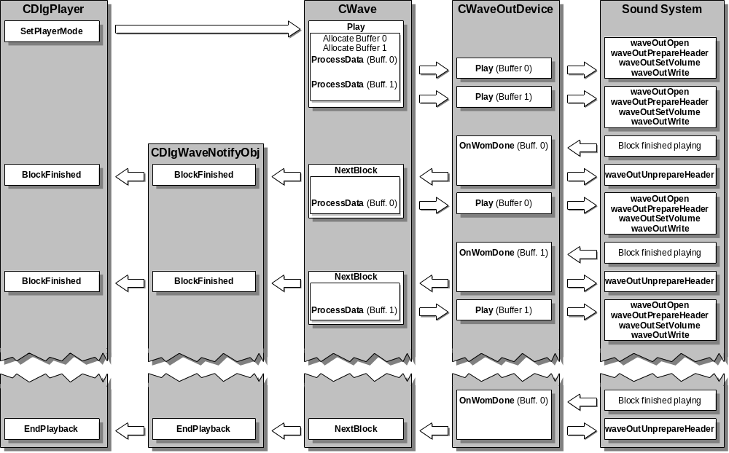
The wave processing (ProcessData) function processes one block of data. If it does not need to change the data (plain mode for 100% replay speed), it has at least to find the maximum audio level in the data (for display purposes in the player) and copy the wave data into the player buffer. The function CopyBuffer does this. If it needs to change the replay speed, it calls WaveWarp, to do this. ProcessData can get the wave data for the process from different sources. To get the data it calls the notify objects (m_pNotifyObj ) member function GetWaveData. This function delivers the data from the document (by using the right source file in case of workbench processed data) if the player is playing or from the newly created temporary wave file in the recorder if the recorder is playing. Be sure, to get your wave data only through this function in CWave. There is so much time for the whole data processing, as a wave data block takes to play back. You have 372 ms for 44’100 Hz, 16 k block or 11’025 Hz, 4 k block size.
The recorder is a modal dialog, called by the view. It is able to play back a recorded piece of wave data in exactly the same way as we saw it for the player. The notify object will just send the messages to the recorder instead of the player. Now let’s see how the recorder records (time runs from top to bottom):
Again while the sound system fills up one buffer, the other one is being stored in the temporary wave file of the recorder. We got a disk based recording system. The recording goes on until the user calls the Stop member function of CWave, which resets the input device.
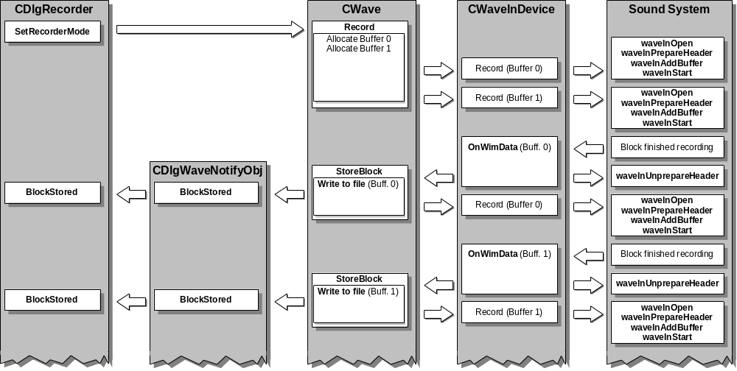
Besides the record and the play back capability the recorder also has a monitoring mode. This lets the user see the audio level before (or after) recording. Whenever the recorder does not record or playback, it monitors. Monitoring works in the same way as recording does, but it does not store the received wave data in a file.
The recorder has a built in high pass filter to eliminate the unwanted low frequency part in the speech spectrum below 70 Hz. The user can turn the filter off or on in the settings. As soon as a recording has been stopped, the filter runs through the data and changes it in the temporary wave file of the recorder. The call to the filter (HighPassFilter) is placed in the recorders member function SetRecorderMode.
The recorder creates a new temporary wave file, every time it becomes called. The application CSaApp creates the new document and the view and calls the recorder in the message handler OnFileRecord by sending the message WM_USER_RECORDER to the newly created view, which actually starts the recorder dialog. Then the recorder function creates the temporary wave file in the function SetRecorderMode in case of IDC_RECORD (user pushed the record button). It always deletes an existing older temporary file and creates a new one. CreateTempFile creates a temporary file in the Windows™ temporary directory with a RIFF structure, the format chunk and the data chunk. The format chunk contains no valid data, but the space for the data. The file stays open with the file pointer at the beginning of the data chunk. The recorder can start writing recorded data immediately. If a recording has finished (user pushed the stop button), SetRecorderMode case IDC_STOP just stops the recording (does the high pass filtering) and lets the file stay as it is. The user needs to push the apply button to apply the recorded data into the document. The message handler for the apply button OnApply calls Apply with a pointer to the document, where we want to apply to. Remember, the file is still open and the format parameters are empty yet. The size of the recorded data is stored in m_dwRecordSize, which has been updated by every call from the notify object in BlockStored. Now what Apply does with the wave file may seem strange to you, it does to me too. But I spent some time to figure out, how to make apply work and have the file close itself with the proper RIFF structure and data size. It works how it is, don’t ask too many questions. After having written the RIFF structure, we fill in the format parameters and prepare the sa parameters for the document. Finally we call the documents ApplyWaveFile to apply it. Then we can close the recorder with calling CleanUp first, which deletes the CWave object (the wave file will not be deleted in this case, because m_szFileName has been emptied during the apply operation, the file belongs now to the document) and frees the buffer. This buffer has been used as wave data read buffer. As we saw before, the recorder is able to play back the wave data from the temporary wave file and therefore it has to be able to read and buffer the data in the same way as the document does. For this reason the recorder has the buffer and the member function GetWaveData.
If the user does not apply the recorded data and just closes the recorder, the view and the document will close too, because there is no data for them. We do this in the view. If the modal recorder dialog does not come back with IDOK, we send ID_FILE_CLOSE to the view, which closes the view and the document. We don’t allow the user to change format parameters while having a recording session. If he wants to change the settings, he has to do it before he does a recording. We tell him, if he wants to do it anyway, we will delete the already recorded wave file. This is necessary, because we record the wave data with a particular format, which is unchangeable after the recording has been done.
Both, the player and the recorder read and set the system audio volume. They set it by playing back and calling waveOutSetVolume. Reading the volume is more complex, because it has to happen before the recorder/player dialogs finish building up on the screen. We want to see the volume sliders in the right position. The CWave class has a member function called GetVolume. This function calls the output device member function GetVolume. There we have to open the output device if it was not before. We have to read the volume and to close the device, if it was not open before.
Another special thing is the repeat function in the player and the recorder. The repeat function works with a timer. As we saw before, when the playback finishes, the notification object calls the function EndPlayback. There we start a timer with the delay time setup by the user, if the repeat function is turned on. The message handler of the timer starts another playback by calling SetRecorderMode.
Another thing to mention about player and recorder is the function key dialog. We provide a function key system for the user, to simplify play back functions (similar to WinCECIL). The function key setting is stored in the class FnKeys, owned by the mainframe. This class also has the capability to store and restore the settings in SAs settings file. The user can setup the players parameters like replay volume, speed, what to replay etc. Then he can assign a particular setting to a function key, which he can activate by pressing Ctrl + the key. Unfortunately, a lot of the function keys (actually most of them) are already used by the Windows™ system or are used for standard Windows™ functions. So we had to use the Ctrl key together with the function keys. If the user pushes this combination, the active view becomes called in the message handler OnPlayFxx, which one calls the player. Because only the active view gets the message, the function keys won’t work, if the player or the workbench have focus. The function key setup dialog is called in the player (OnSetup). The player knows, if the setup dialog is running or not (m_bTestRunning). This is important, because the mainframe needs to know too. The notify asks the mainframe, where to send its messages and if the function key dialog is playing back, it needs to receive the calls from the notification object. With this, we already saw, that the function key dialog is able to play back. It has his own CWave object and runs function key setup test runs.
Because the player is a modeless dialog, the user is able to exit from the application while the player is up, even while it is playing. Therefore the mainframe (owner of the player) needs to be informed before closing the application, so that it can stop the player playing back and close it properly. The mainframes message handler OnClose does this job with the player, also with the workbench and the find/replace dialog.

Processing
This chapter only speaks about the graph processing and not the workbench processes (see chapter “workbench”). Processes are owned by the document. It creates and deletes them all at the same time (in its constructor and destructor) and it has member functions to deliver a pointer to every single process object. Every process object got the same basic structure and the same interface from the base class (CDataProcess):

A process has a body of member functions and data, with a buffer (same size as the documents read buffer) for data buffering and a temporary file in the Windows™ temporary directory with the processed data. The Process function does the real work by processing the necessary data, creating the temporary file and storing the data into it. The buffer and the file are created, when the process starts (not before). They will be deleted in the destructor of the process.
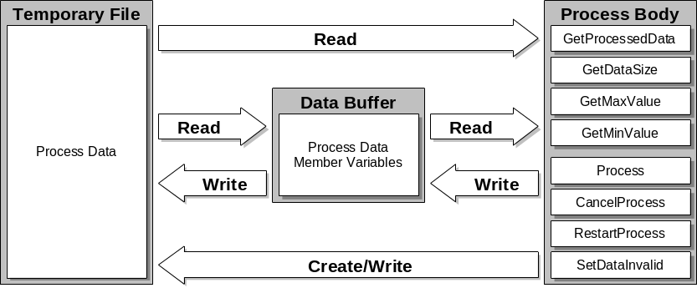
This kind of process always processes the whole wave data. It reads the wave data from the document. There is another kind of process, derived from CDataProcess, the CAreaDataProcess class. This class, with exactly the same structure as shown above does not process the whole wave data, but only a part of it called area. It needs of course to store the area boundaries. It is able to handle an almost unlimited number of areas. The boundaries are stored in dynamic arrays and every processed area gets its own temporary data file.

Calling a Process
A process should only be called, if data from it is needed. This is the way it is implemented now. It means, that if SA does not show any other graphs than the wave form graph, there will be no data processing. As soon as the user requests a graph, which one needs processing, the process will be called and the user will have to wait for the result. Then, because the process data is stored in a temporary file, it will be ready all the time and the next time the same graph will come up immediately until it becomes deleted. Right now, a process becomes called from the graphs plot, from its member function OnDraw. Whenever the plot needs to draw something (from the processed data) it calls the process. A pointer to the process object can be gotten from the document and the following call of Process will cause the process to check, if there is already processed data ready or not. If it is not, the data will be processed. The caller gets a answer to his request by calling CheckResult (member function of CPlotWnd). It sets up a the helper window with the appropriate text, if the process has been canceled and it closes the graph (with a message), if there was a processing error. This is necessary, because in case of a processing error there is no data to draw. If we would not close the graph, it would try to process again the next time OnDraw becomes called. It even could cause an endless loop. Return immediately from OnDraw, if CheckResult returns PROCESS_ERROR. Now CheckResult returns 0, if there was no processing necessary (data already present). It returns a number of 1 or higher, if there was processing, but without problems. After that you can use the processed data. Get it by calling the process helper functions like GetProcessedData, GetDataSize etc.
For area processed, the calling procedure is more complex, because there can be several (up to 32k) areas in the same process. Therefore the caller needs to identify its area. You need to get an ID number from the process class for all the calls to it. Get the number as early as possible, for instance in the OnCreate function of the plot. Get the pointer to the process there from the document and then call GetNextIndex (member of the area process), to get and store your special private ID (index). GetNextIndex creates a new entry (if there are no empty slots) in the dynamic data arrays and initializes them. It will be deleted by calling FreeIndex (member of the area process), from the plots destructor. Now with this ID, you can use the same procedure as for the normal process. The process will process wave data between the actual cursor position. There is one other difference: An area process can have an idle state, which means, there is no data processed yet, but the plot is there already. This state is initialized after creation of an area graph. You should check for it in the OnDraw function of your area plot. Use IsIdle (member of CAreaDataProcess) for this and set up the helper window, to tell the user, that he should start the process by positioning the cursors and recalculate (see “restarting a process”).

The Process
Now let’s see how the processing itself works. We will step through a standard Process function and you need to keep the discussed order and to do the mentioned steps. Process gets a very important parameter, called nLevel. Its content is 1 by default, which means, this is a top level process. Look for more information under “process nesting”.
Normally we check for the canceled state first (flag m_bCanceled set) first and return immediately, if the process is canceled (see “canceling a process”). Next we check, if the data is already ready (flag m_bDataReady set) and if yes, we return immediately. To return properly from a process you need to return a long number with the process level - 1 in the lower word and the progress in the higher word. The level is used for the result check in the plot and for the process nesting. The progress is a number between 0 and 100 (included) and it is used for the progress bar and the process nesting. Then first call the nested processes, from which ones you need to get data (see “process nesting”).
Next, we set up the hour glass and then we switch the status bar and show the progress status bar on the screen by calling StartProcess. It returns a pointer to the progress status bar object, which we save, because we need it later to update the progress bar. StartProcess takes a text ID (from the resources) to show the right text on the status bar while processing. It checks, if a process is running already (previous owner). It only calls the mainframe, to show the status bar on the screen and initialize it, if there is no process running already. This allows proper nesting of processes, no flickering of the status bar and a properly working progress bar. StartProcess also allocates the process buffer (m_lpData is the pointer to it). From this point on, you need to exit in a different way. Always call EndProcess, which will call the mainframe to set back the status bar and set the cursor back to its original state.
Before being able to store data in the temporary file, you need to create or (if it already exists) open it. For this reason call CreateTempFile. From this point on you always have to exit by calling Exit. Exit will take care of all the necessary clean up and also delete the temporary file.
The calculation of the processed data needs to be split up in little pieces (at least 5), because we need to show the progress to the user. Therefore the calculation code is placed in a loop and in the loop we call SetProgress (member of CProgressStatusBar). The parameter should be a value between 0 and 100 (percent) and represent the calculation progress. Normally you calculate it with nProgress as minimum value and added to it your progress divided by nLevel. This method will make sure, that nested processes still show the proper progress level. nProgress contains the end level of the previous called process and nLevel is the nesting level of the current running process (1 means top level). So SetProgress sets the progress bar and very important, it calls MessageLoop. This function lets pass the keyboard messages during processing. It makes sure, that the user can cancel a running process (see “canceling a process”).
Now all the preparations are done to be able to safe data in the temporary process file. Use the file object m_pFile and at the end of the process don’t forget to update the file status (m_fileStatus). The procedure to finish up a process is always: close the temporary file (CloseTempFile), update the file status and call EndProcess. If the parameter of EndProcess is TRUE, the mainframe will switch back to the data status bar, so pass only TRUE, if the process is really finished (progress >= 95%). Then switch back to the normal cursor and set the flag m_bDataReady, to signal, that the data is ready and return with the level and the progress.

Process Nesting
Processes can be nested. Not every process needs wave data as source, some of them need data from other processes and these other processes need to process first. If you need processed data from an other process in your process, call the needed process first. This called process may be needs other processed data and will also call an other process first, but you don’t need to worry about that if you keep the right calling conventions. Call the needed process by getting a pointer to it from the document and calling its member function Process. Be sure to increment nLevel before passing it to Process, because the process will be one nesting level higher than the calling one. The called process will come back with a new level in the lower and a progress in the higher word of the result. The new level is below zero, if there was an error in the process or if it has been canceled by the user (check it out!). If there was an error, the level will be PROCESS_ERROR, in the case of cancellation PROCESS_CANCELED. Now very important: if the called process has been canceled by the user, its cancel flag will not be set, because it is not the top level process (this has been checked by Exit). But your process might be the top level process. If it is, set your cancel flag (m_bCanceled). If we don’t do it this way, we would cause all kinds of problems. For instance, if the top level process does not set its cancel flag, it won’t be recognized as canceled by the graph (but there is not data ready). Or if the lower level process also has its cancel flag set, it would return canceled state to the graph, that uses it as top level process etc. The newly returned value for the progress is the return value of the called process (end progress) and is used as a base value for the next process.

Canceling a process
As we saw before, if we call SetProgress periodically (which calls MessageLoop), the keyboard messages will pass and be processed by the MFC framework. We have a message handler for the Esc-key, which one besides stopping the player also cancels processes, in the view (OnKeyDown case VK_ESCAPE). To cancel a process, we need to find out, which process is running right now. We saw before, that the progress status bar stored the caller and the owner of the running process. Therefore we can get a pointer to the bar from the mainframe and get the process owner from it (GetProcessOwner). If there is one (not NULL), we call the process owners function CancelProcess. GetProcessCaller needs the caller of the process as parameter. We can get it also from the progress status bar (GetProcessCaller). CancelProcess just sets the cancel flag m_bCanceled in case of CDataProcess processes. But for CAreaDataProcess processes, it needs to get the index for the currently processed area from the process caller (the plot).

Restarting a process
A canceled process needs to be restarted from the user. An area process needs to be restarted to recalculate or to calculate for the first time. There are two ways to do it. If we press the return key, the view will receive the VK_RETURN message. We have an accelerator key defined in the resources for this key. It will cause a message ID_RESTART_PROCESS. The same message will be sent, if we press the ‘Recalc.’ button of an area graph (this button is not a real button but just a drawing with hit test). It is placed in the legend window and OnLButtonUp of CLegendWnd sends the message (if there was a OnLButtonDown before). The view has a message for this message (OnRestartProcess). It calls RestartProcess of the graph with focus. The RestartProcess function calls the plots member function RestartProcess, which one hides the helper window in the plot, calls the process member function RestartProcess and then redraws the plot. Now RestartProcess of the process just sets back the cancel flag for normal processes and because the plot redraws after that, the process will restart. For area processes RestartProcess also sets back the cancel flag, but also clears all the other flags (only INDEX_TAKEN is set to signal, that this area is used) and deletes the temporary file. It will be created again when the process restarts.

Special Processes
There are some processes, which use special methods to calculate the needed data. The change process for instance calls SmoothData, a filter function to low pass the data. Or there are processes like pitch, which create not just one but two resulting process files. Pitch creates raw pitch and quality. The formant process uses an enhanced filter class (CFilterProcess), with a median filter implemented. I don’t document these things deeper, because I did not write the code for the low pass (it is taken from WinCECIL and adapted to C++) and never looked at the CFilterProcess class, written by Doug Eberman. There are a couple of special process classes prewritten for experimental use (files ‘sa_p_spe’). These classes are linked together with special experimental graphs (files ‘sa_g_spe’). If you need to try something in a new graph, use one of these plot B...H. Just put its checkbox (ID IDD_PLOTB ... IDD_PLOTH) into the graph types dialog resource, to be able to select it. All the other code for it should already be ready to run. Just modify it for your purposes.
We will discuss the special workbench processes in the chapter “workbench”.

Process Parameters
A lot of the processes are dealing with a user setup which influences the process. Normally the document owns the parameter set, initializes it in DeleteContents for every process and the process and the dialog get it from the document. But there is one exception (besides the workbench processes): The Spectrogram. It keeps its own parameters, because it is an area graph and every graph has its own set of parameters. There is a set of dynamic arrays for the spectrogram parameters in the CProcessSpectrogram class. The maximal number of spectrogram graphs is limited only by the maximal array index (32k).

Graph Overlay
The whole graph overlay part was programmed by Doug Eberman. I will not be able to discuss every detail of his code, but I’ll try to give an overview, how it works. The overlay plot is just another plot, derived from the plot base class CPlotWnd. The multi plot class CMultiPlotWnd (this is how the overlay plot is called) is able to handle a number of MAX_PLOTS. It uses every plots own drawing mechanism to draw the data into the original plot. Even plots from other views can be drawn into a multi plot. The colors, how the data is drawn are a special color setup. Therefore, to have a plot drawn with the special overlay color, he calls the mainframes member functions SwapInOverlayColors and SwapOutOverlayColors, which change the normal color of the particular plot to the overlay color and after drawing has finished, back again.
Because the overlay plot only uses already present plots, it doesn’t have to deal with processing first, creating plots etc. But if we overlay plots from different views, we need to make sure, that we don’t close a view, whichs graphs are used as overlay graphs in another view. Or we need to remove the used graph from the overlay automatically. Right now we check, if all the views of the overlaid graphs still exist and if not, we remove the affected graphs from the multi plot list.
The dialog used to add and remove overlay graphs is the CPickOverlayDlg object. If the user chooses a graph to be an overlay graph, the graph with focus will be changed to be an overlay graph (see the views message handler OnPopupgraphOverlay). This happens in the CGraphWnd class in the member function MergeInGraph. It actually copies the graph object but with an overlay plot of the same type and then deletes the old graph object. Then all the selected overlay graphs will be merged in (same function which calls the multi plots member function AddPlot).
If the last overlaid plot of a multi plot becomes deleted, the graph will be changed back to a normal graph type, which it was before it became an overlay graph (see the views message handler OnPopupgraphDelOverlay).

Settings
The settings code was originally written and used for Shoebox for Windows™. Because like Shoebox we also want to be able to run SA on a Macintosh® later, we cannot use the MFCs standard ‘ini’ file setting system. We use the same system as Shoebox does with its own special settings file. The file which contains finally the SA settings is a text file in the same format as a Shoebox data file. We refer to the special documentation for this settings system. I just have some general comments about how we implemented the system (done by Doug Eberman). We save all the settings for SA in one settings file, which one will be created in the same directory as were the executable is and it will be called ‘sa.psa’ (don’t ask me what the extension means). We store the workbench settings in a different file (see chapter “workbench”). SAs settings file contains two different sets of settings. One is the standard setting, which contains colors, user setup parameters, MRU-files list, setup of the MRU-views etc. It does not contain any process parameters. Then there is a second set, which contains the setup, how a newly opened view has to come up (graphs, annotations, layout etc.). Be aware, that a view created by the recorder or with “paste as new” does not come up in this way but always only with the wave form graph, because we don’t have the data ready yet for graph processing for this views.
Now every object, which wants to be able to save and restore its settings has to have the file ‘settings\obstream.h’ included and the two functions WriteProperties and bReadProperties implemented. There you define, which variables will be saved/restored. Then we need somewhere a writer and a reader, which calls all these save/restore functions. The top level reader/writer is implemented in the CSaApp class. ReadSettings is the reader (called from InitInstance) and WriteSettings the writer (called from the mainframes OnClose message handler). The writer is also called directly from the tools options dialog, if the user chooses to save the settings ‘now’. The reader calls the top level bReadProperties in CSaApp, which one calls the lower level readers, which call again their lower level readers etc. The writer calls the top level WriteProperties in CSaApp, which one calls the lower level writers, which call again their lower level writers etc.
Their is one important point about batch mode. In batch mode (SA called from data base program) we are not allowed to restore all the settings, because the caller tells us, which files we have to open (not the settings). So in this case, we just restore the general settings.

Printing
The whole printing system was written by Doug Eberman. I never looked into it, it looks quite complex and I know, there is a lot of work and trouble behind it. Without a very big effort to read into the code I am not able to explain how it works. The only thing I really understood is the way the plots print to the printer. We use a lot of MFCs framework and we also can use the same drawing routines for printing as for drawing on the screen. We just have to switch the target device and to resize the drawing areas. This is why we have an OnPaint function, which calls an OnDraw function in the CWnd derived classes. OnDraw becomes called with the right device context and the adjusted rectangles.

Workbench
The workbench is realized with a second document template and we use MFCs features for multiple document applications. We register the workbench template in the applications member function InitInstance. The CWorkbenchDoc class represents the workbench document, the CSaWorkbenchView class the view. There is just little difference in the way, the document view system of the workbench differs from a standard implementation. One difference is, that we open the workbench (besides the normal way with the file open dialog) with a menu item in the main menu “Window” submenu. We need this second possibility, because we don’t have the workbench view visible all the time, but we still have its functions active. Therefore the user needs to have a way to make it visible, without opening a new workbench file. Then the other difference is the views base class: It is an object derived from CFormView. This means, It has a dialog resource. This makes the graphical and the user interface much simpler.
When SA starts up it restores from SAs general settings the path and name of the workbench file to open. If there is none, it loads the filter IDs from it and creates the appropriate processes. The filter IDs and the pointers to the processes are stored in dynamic arrays (m_apWbProcess, m_aWbFilterID) owned by the mainframe. This is the right place to store it, because every wave document needs to be able to get the pointers and the workbench view and document are not always open. The maximal number of processes and filters is defined in ‘appdefs.h’ by MAX_PROCESS_NUMBER and MAX_FILTER_NUMBER.
If we speak about filter IDs and workbench processes, we think of ordinary wave data processes derived from CDataProcess. The workbench processes are called filters in the user interface. Every process has an ID, which we call filter ID.
If the user checks the Workbench item in the main menu, he wants to see the workbench in the same state as it was the last time he saw it. Because we read the workbench settings after having started up SA and opened its workbench file, we were able to create the workbench processes already. Now to make them visible, we have to create the workbench view and the document. The message handler for the workbench is a member function of CSaApp and is called OnWorkbenchOpen. There we open (or if already open) or close the workbench view. We use MFCs standard function to do this but have to make sure, that the workbench’s file path and name is always up to date. It is stored in m_szWbPath (member of CSaApp) and used to store the actual workbench file in SAs general settings. The workbench document class CWorkbenchDoc contains nothing but some necessary file handling functions and setting up of the caption text. All the work with the processes is done inside the workbench view CSaWorkbenchView. But again, it is not too much of work. The view just has to bring up dialogs for the user to choose filters, create the filter processes and store them in the mainframes arrays. It looks sometimes more complex, because we have to align the filters to the left and fill gaps (graphically spoken) and because of the nesting procedure of the processes, we have to store the filters in reverse order (last one first). The workbench processes need to be created in the process dialog (CWbDlgProcesses) at the time, when the user selects a new process, because we want to give the possibility to the user, to call the process properties dialog immediately. For this reason, we need the process object, because it owns its properties dialog itself.
There is a special graphical problem with the form view. We use the frames with caption text in the dialog resource for the workbench view, but the caption text does not use the right background color. We had to create a special text window (CStaticText) and overlay it to the caption text (you might see the screen flickering). To have the view use the dialog background, we had to create the background brush (m_brBkg) and implement OnCtlColor to use this background. There is also a bug fix for the form view with the message queue in PreTranslateMessage.
The two functions CreateWbProcess and GetFilterResource build the links between the filter ID, the process and the right bitmaps.

Workbench Processes
We saw before that workbench processes are ordinary processes derived from CDataProcess. But this process base class got some special features for workbench processes only. We already discussed the wave data access in the wave document and how it uses the three functions GetProcessedWaveData, GetProcessedWaveDataSize, GetProcessBufferIndex, GetProcessFileName and DeleteProcessFileName. They make it possible for the wave document to access processed data in the workbench processes. Then there are the PropertiesDialog functions (virtual) for every workbench process a little bit different. These functions call a workbench process properties dialog to let the user set up the properties for every workbench process. This also means, that workbench processes own their calculation parameters. We also got functions to deal with the process range. Workbench processes are able to apply a calculation only to a part of the whole wave file. It is different than the system of the area processes, because the workbench processes keep the original data outside of the area and they deal with just one area (range) per process. The range is just a number stored in m_nRange. At last we have the settings functions WriteProperties and bReadProperties (virtual). Every workbench process saves and restores its own settings (calculation parameters).
How does a workbench processing session work? First, we setup and create the processes with the workbench views functions and the workbench dialogs. The pointers to the processes are stored in the mainframes workbench arrays. To start processing, the user chooses the process he wants to apply to the wave data in the parameters dialog of the wave form. It happens in the message handlers OnGraphsParameters and OnPopupgraphsParameters. If the parameters dialog comes back with IDOK and a there was a change in the process selection, then the active document gets its variable m_nWbProcess set to a process number (1... MAX_PROCESS_NUMBER). It is very important, that the parameters dialog disappears from the screen before the processing starts. If the dialog still has focus, messages won’t go to the view but to the dialog and you get some problems like the one with the process canceling, which does not work. So we first delete the dialog and then call WorkbenchProcess (member of CSaDoc). This function gets the appropriate workbench process pointer (the top level process) from the mainframe and starts processing. If there was a process error, it switches back to plain (no workbench process). If there was no error, the wave data source is now the temporary file of the workbench process and therefore all the graphs need to recalculate (InvalidateAllProcesses). The processed top level process works like the graph processes and uses process nesting techniques. It calls first the next lower level process (if present) and this one also calls the lower one (if present). As we saw, the difference in processing lays in the range. The workbench process copies to source data unchanged to the target, unless it is within the range.
The user has the possibility to save the data of a workbench process as wave data. The CSaDocs member function OnFileSave deals with this part. In case of an active workbench process it replaces the documents temporary file, which contains a copy of the original wave data, with the temporary file of the workbench process (it asks the user before). It then deletes the documents temporary file, switches the document back to plain (no workbench process, because the processed data becomes now the normal wave data) and invalidates the process. Right after the call of OnFileSave, the framework calls OnSaveDocument, which saves the temporary file contents to the original wave file.

Workbench Settings
This part is a little bit tricky, because we restore workbench settings while starting up SA, but we close the workbench view again (if the flag m_bWbOpenOnExit of CSaApp is not set) and bring it up again later (by user request) without restoring the settings. In general, the settings work in exactly the same way as for the rest of SA. Bu we also save the process parameters. The top level reader bReadProperties (member of CSaWorkbenchView) becomes called by the workbench’s document handler OnOpenDocument. In bReadProperties we first check, if this is a different file than the last one was (the workbench document knows it). If it is different, we need to delete all the existing workbench processes by calling the mainframes member function DeleteWbProcesses. This function also checks, if a process has been used by a wave document and if yes, it switches the document back to plain. Then we read the settings and immediately create all the necessary process objects. If there was a settings reading error, we delete the created processes.
The top level writer WriteProperties (member of CSaWorkbenchView) becomes called by the overloaded MFC function OnSaveDocument in the workbench document.
There is a piece of code in the mainframes OnClose message handler, which one closes the workbench, if it is open while closing the mainframe. If the workbench settings changed, the user will be asked from the framework, if he wants to save the changes in the workbench file. If he cancels, the mainframe will not close. The flag m_bWbOpenOnExit of CSaApp is used to remember (it is saved in SAs settings), if the workbench was open on exit or not and SA will come up in the same way the next time, if the settings have been written on exit.

Character Table
There was very little time to write the character table classes (5 days) and I wished, I would have had the time to figure out, how I can separate the resources for the property pages of the character table from all the other resources. Right now they are together with SAs resources in the same files (‘sa.rc’ and ‘resource.h’) and if you need the character table in a different application, you have to separate the resources. The other classes are properly separated from the application. There is a standard calling sequence for the table. Copy it from the CDlgInputs member function OnCharacterChart. Notice that you need the caption text from the resources IDS_DLGTITLE_CHARCHART and you need to set up the font you want to see in the table. The result will come back in the member variable m_szString of CDlgCharChart.
You need from the resource file ‘resource.h’ all the constants, which contain the string ‘_CHAR’ somewhere in the name. Then you need from ‘sa.rc’ the four dialog resources IDD_CHARTVOWELSPAGE, IDD_CHARTCONSONANTSPAGE, IDD_CHARTDIACRITICSPAGE and IDD_CHARTSUPRASEGSPAGE and again all the string resources, which contain ‘_CHAR’ somewhere in their name.
The character table property sheet class CDlgCharChart is derived from CSheetSA. So you need this class too (‘sheet.cpp’ and ‘sheet.h’).
The character table property pages layout can be edited in the resource editor. You will see a lot of little static text windows, which stand for the special window, which will be overlaid over them in runtime. There are three different types of special windows: CChartText, CChartLine and CChartChar. The first one is a window, which displays text in different formats and with lines at the window borders. The second one displays just lines in different ways (also diagonal) and with dots at the ends (if you want). The last one displays a string (or one character) again in different ways (highlighted, grayed etc.) and with the character table font. It also has the pop up window (you can turn it on/off) with the enlarged characters for better readability. This pop up window comes up with a timer, if the mouse cursor stays for a certain time (ZOOM_DELAY) over the window. It is just another CChartChar object. Every window has the Init member function, which is used to set it up. All the possible parameters for the special windows are defined in their class definitions.
The text and line windows are set up in the appropriate property pages member function OnInitDialog, but the character windows are different. The character table classes are designed to be as generic and flexible as possible and they allow more than one set of characters or more than one font to be used in the table. You can not mix the fonts, but you can switch between them. You also can bring up a selection out of the whole table like for instance just the characters, which appear in a database (or just highlight them, or gray out the other ones etc.). Let’s see how it works.
The character table property sheet object owns an array of pointers to CCharTable objects. Every of these character tables contains a set of characters assigned to the character windows in the property pages. If you create a new set, derive your class from the CCharTable base class, like I did for the IPA set in CIPATable. The member function SetupTable contains the setup of the characters (or strings). The base class has the member function SelectChars, with which you can select and highlight or gray out etc. a character. You just pass the character (or string), you don’t need to know the window ID or anything else. Now to set up for instance the vowels property page, the OnInitDialog function becomes called first. There we get the font for the text windows by calling the parent property sheets member function GetTextFont. The property sheet did create the font from a copy of the standard dialogs static texts font and modify it to not bold. Then we set up all the text windows and the line windows by calling Init. After that we call the parent property sheets member function GetTable to get a pointer to the character table we want (e. g. IPA) and we call the character tables member function InitPage with the parameter VOWEL for this vowels page. InitPage initializes all the character windows by calling their Init function. Before, the character table was just setup and stored in an array, but the windows were not created. The table was setup before the property sheet dialog was started by the call of SetInitialState (member of CDlgCharChart ) which one called SetupTable (member of CCharTable).
Now all the windows are created and overlaid over the original dialogs static text controls. If a mouse click on a character window happens, it sends a message to the property sheet, which then in the message handler OnCharSelect puts the selected character (or string) into the edit control. There is also a combo box in the property sheet, which you can use to do whatever you want, like selecting (or highlighting) parts of the chart. Put your code in the combo box message handler OnDisplaySelChange. To highlight a character get a pointer to the character table you want from the property sheet and then call its SelectChars function with the parameters you need. The combo box, the edit control and the two static texts in the property sheet below the property pages are setup in the property sheets message handler OnCreate. The deletion of the apply button and the repositioning of the other buttons happens in the property sheets member function ChangeButtons, which one becomes called from the property sheets OnInitDialog.
The table worked fine on Windows95™, but unfortunately, it took too many resources on some older PCs with Windows™ 3.1x. The reason were the many windows we create for all the property pages. So in some cases not all the character windows showed up on the screen. The solution for this would be, not to overlay windows over the static text controls, but to subclass them. The message handling will be more complex (this is the main reason not to do it) if we do that, but there will be just half of the number of windows. For now I got a solution, which works fine but is a little bit slower. In the special overlaid windows Init function I destroy the original static text window. We don’t need it anymore, it was just to show us the position for the overlaid window. This trick reduces the number of windows by 50%, but you will see, that if you create a character chart property page for the first time, it builds up slower.

Miscellaneous
Special Dialog Windows
There are several special windows for dialogs, I didn’t mention in the text before. All these windows are built to become overlaid over a static text window in a dialog.
The CLEDDisplay class is able to display a neat looking LED style time display. It uses a bitmap (resources) with all the possible characters defined in it in a row and then it just puts the one it needs to the screen a the right place.
CSliderVertical and CSliderHorizontal are classes used to show slide bar controls. They exist in newer MFC libraries (32 bit only). We mostly use them together with a edit control and a spin control.
The CVUBar class shows a VU-Bar on the screen. It is a stereo display, and the class really handles stereo data (two channels). Every channel has a peak indication system and you can setup the dimensions and the divisions of the bar by constants in the class definition. The bar needs to be fast in drawing, because it draws while playback needs a lot of free time to process data. Don’t use the API function UpdateWindow, because it forces the system to update the window, even if there is no time to do it. I could eliminate some timing problems on slower PCs with record and playback functions by eliminating these calls.
The CComboGridlines class is different, because it is derived from CComboBox and then subclassed. It draws a number of gridlines in the list to choose.
The CSpinControl window is a spin control (two small buttons) which again exists in newer 32 bit MFC libraries. It has a repeat function built in with a timer and it also can gray out. It uses the keyboard delay to set the repetition delay (SPI_GETKEYBOARDDELAY).
CToggleButton is a button, which toggles, which means it stays down if you push it and it comes up by pushing again. It also has a blinking function (with timer). There is a set of different buttons implemented.
CTranscriptionDisp is just used in the file information dialog to display transcription information (phonetic). There is some code to make split the string nicely into different lines and cut it, if it does not fit into the window.
CAboutTitle is used in the splash window (a modeless dialog) and the about dialog. It draws the big SA title.

Property Sheet Fix
There is a fix from Microsoft® for the bugs in MFCs property sheet code. We use the same class as the Shoebox team used for their code, but we did some more fixes. The class is called CSheetSA, derived from CPropertySheet and all the property sheets should be derived from this class. We changed the function PreTranslateMessage to make the return key similar to the click onto the OK button. We also force the apply button to have focus to get all the changes especially in edit controls, if the focus is still in one of this control by pressing the apply button.

Layout Menu
The layout menu with its 3D layout drawing is implemented in the class CLayoutMenu. We draw the menu items with system colors and we also take the system (OEM) bitmap to draw the check mark. The layout menu needs to be attached to a pop up menu in the main menu and in the right mouse pop up menu for graphs.
The main menu has an initialization handler in OnInitMenu of the mainframe. This function becomes called every time a menu initializes in the mainframe. We need to attach the layout menu just once and only in the main menu. So we first check, if the menu contains more than six items. This is necessary, because the mainframe has a much simpler standard menu, if there is no file open. We must not try to attach the layout menu there (the appropriate pop up menu item would not exist and it would crash). As long as this menu has less than seven items, but the main menu has more than six, this check works. Then we check of course, if the menu has already been attached. If it had, the flag m_bMenuModified would be set. The last check is for floating pop up menus. We only attach, if the pointer to the menu, which initializes is the same as the one to the mainframes main menu. Or in other words, if the menu to initialize is the mainframes main menu. If we pass all the checks, we attach the menu object m_LayoutMenu to the menu item with the ID ID_GRAPHS_LAYOUT. Then we set the flag bMenuModified.
Similar to this is the attaching procedure for the right mouse pop up menu for graphs. It is located in the right mouse click message handlers OnRButtonDown of CPlotWnd and CLegendWnd (both windows bring up the pop up menu for graphs). There we know, that the layout menu is always to attach, because we just are bringing up the pop up menu. We get a pointer to the submenu 0. Be aware of the design of the pop up menu in the resources, which contains all the used pop up menus in one big menu resource. The graph pop up has to be the item zero, otherwise the layout menu will not attach but crash. Then we attach the just created layout menu object and pop up the menu.

Document List
The document list is implemented in a class, written by the Shoebox team. It is called CDocList and used by the mainframe in several places. It makes it easy to step through all the open documents (list of documents). Because it asks only the first document template for the type of document, it only lists wave documents in our case and not workbench documents. This is exactly what we need. We use the document list in the mainframes function SendMessageToMDIDescendants, to send a message just to the active vies of the open documents. Or we need it in OnApplyToolsOptions to check for open documents in case of a user change of the wave buffer size and to close all the documents. Other applications are OnUpdateEqualizeLength and IsProcessUsed to step through the list of open documents.

Equalize Length
There are two little pieces of code, written by Doug Eberman, for this feature. One is the menu update handler OnUpdateEqualizeLength, which enables the menu item, if there are at least two documents open. The other is the message handler OnEqualizeLength which equalizes the cursor positions of two different views (if possible). It uses the dialog class CTargViewDlg.
Find/Replace
This is another piece of code from Doug Eberman, which I never looked at in detail. I know, that the functionality is aligned to Microsoft® Word™ for Windows™ Version 6.0. Doug uses one dialog resource for both, the find and the replace dialog and then he changes its size and moves around the controls for the different uses.

Changing Focus or Closing a View
This is a little bit special, because if the player is up (modeless dialog), it needs to be informed about which view has focus (it plays data from this view and it displays the document name in its caption). Because the player is owned by the mainframe, the mainframe needs to know, if a focus change happens and it needs to be informed, if a view closes and especially if the last view closes. Then it also needs to close the player (there is no data to play anymore). The mainframes has a member variable m_nNumberOfViews, which contains always the number of active wave views. This number is kept up to date by the views themselves. They call the mainframes member function ComputeNumberOfViews to increment the number in their OnCreate message handler (view creation) and they decrement it in their message handler OnDestroy (view destruction). The views check, if the last view has been destructed and send the message WM_USER_CHANGEVIEW with the flag in wParam reset if yes. Now the mainframe handles the message in OnChangeView. There it closes the player, the find/replace dialog and clears the status bar panes in case of the last closed view. The same message WM_USER_CHANGEVIEW becomes sent by the views, in case of a focus change. In this case the flag in wParam will be set and OnChangeView only informs the player and the find/replace dialog by calling their member functions ChangeView. The views handle the focus change in OnActivateView. Besides informing the mainframe, they have to redraw the focused graph (to represent the right state), to process the workbench and to update the status bar. If you set up a workbench process, only the view with focus will process it and as soon as the next view gets focus, it will process. This saves process time and is easier to handle than if we would process always all the views at the same time. It also is in line with the philosophy to process only as much as we need at the moment we need it.

Database Call
SA has a kind of communication protocol implemented, to be able to communicate with a database program (see chapter “database calling procedure”). We already looked a little bit at the startup procedure in batch mode (see chapter “application”) with the list file from the database. SA also returns the list file. It updates it in the list file every time a file changed by calling the applications member function SetBatchFileChanged from the documents member function OnSaveDocument. Now we know, that SA changes the menus and does not allow to exit but only to return to the database. The message handler OnFileReturn of the application handles the return procedure. It has to hide SA and bring up the hidden database program. It sends a message WM_USER_SPEECHAPPLICATION (defined in ‘appdefs.h’) to the window, whichs pointer the mainframes member function IsSMrunning returned. Now to get SA back on the screen, the database needs to send a message to hidden SA. This message is handled in the handler OnSpeechAppCall. There we check what to do appropriate to the parameters of the message.

Suggestions

Processing
Processing is one of the bottle necks in SA. If a process executes, SA is blocked until the process finishes (unless the user cancels it). There is no better way to do it for single task systems like Windows™ 3.1x. But the fact, that graph processes are called from the OnDraw message handler of the plot windows and stay there until the process finishes has some disadvantages:
- There is no easy way to implement a canceling possibility for the mouse, because during the process, we still are ‘drawing’.
- There is no way to write a background processing system for multitasking operating systems.
- The screen is ‘frozen’ during processing and a task change in some special cases can cause problems.
- The necessary keyboard input to enable canceling of a process allows all the keys to pass and this can cause problems.
- If a processing error occurs, we are forced to destroy the graph, because we don’t have any data to draw.
A better implementation of the processing would be, if we would call processing while creating a plot and then make the plot capable to come up, even if the process is still running. As soon as the process finishes, it would inform the plot, draw the data and set up the legend and x-axis window. May be, it sounds nice and easy, but it would be a lot of work and cause a lot of problems. The legend window and the x-axis would need changes, all the plots and also a lot of other functions, because we could no longer assume that the processed data is ready, but it could still be processing. The processes are used also for the workbench and for parsing and segmenting. The new system would need changes in all these parts of the program.
After my opinion it is too late now to make such a basic change. There will be problems coming up, which we never had before and which may be will be very hard to solve.

Segments
The actually used segmenting system is not up to date and too complicated. When I realized, that the system does not meet the needs we have, but is capable of doing things we never will do, I had no time anymore to change it. The segmenting system keeps every single segment for all the five annotations independent with the exception of the boundary alignment for dependent segments. This means, every segment, no, even every single character has an offset and a duration information and the four non text annotations store the character information in a single CString object. This system has following disadvantages:
- It is complicated to find the start and the end of a segment string out of the big annotation string.
- We store much redundant information (offset and duration).
- The user interface is more complicated than it could be.
- There is a lot of code necessary, to apply this system to the real needs.
The system I would implement now, would have the character information stored in dynamic CString arrays. Every phonetic segment would have its CString object and one offset and duration variable. Then all the dependent segments would still have the CString object, but they don’t need any offset or duration, because they are always aligned to the appropriate phonetic segment. They just need an index to the right phonetic segment. This would allow to keep the segmenting information very slim and it would need much less code as we need now. Segment creation would be very easy, all the necessary checks very fast and easy. The user could rumble through all the dependent segments on the screen, even if they would be empty (not created yet). As soon as he wished to fill a string into an empty (not created yet) dependent segment, he just would start typing (or call the transcription editor) and we would add the segment to the dynamic array with the index to the appropriate phonetic segment.
This system would not fit very well with the RIFF header format, which we have now to store segment information. This format should be changed too. It stores a lot of redundant information in a very impractical way.
Now what would it mean to change this system? A lot. Unfortunately, segments are again a key part of SA and their system influences big parts of SA. The system is implemented and encapsulated in segment classes and this would help to reduce the number of changes. But we would need to change these classes totally (rewrite). We would change also the annotation windows classes, the parsing and segmenting processes, the file open and save functions, the find/replace system, of course most of the transcription editor and several other little things. The user interface would change its behavior a little.
After my opinion, this change should be done only, if the segmenting system shows unwanted limits for the user. The change would cause a lot of work and bugs and the advantages for the user should make up for it.

Workbench
The workbench has a very limited graphical interface due to lack of programming time. The number of processes and filters is defined by constants and not dynamic. It has no context sensitive right mouse pop up menus right now, which I would like very much. But there are also not too many possible menu items so far...
The graphical interface should look like a real workbench with a floating toolbar. The toolbar would contain all the possible filters and a connecting tool. Then the user could place a filter somewhere behind a source, a second one, a third one etc. Then he could connect them (with lines). He could also make junctions. This would not be too much work and nice to work with, nice to see. But from the technical and the usable point of view there are not many advantages for this new interface compared with the actual one.

Undo/Redo for Wave Editing
This is probably something SA really needs. It depends, how often wave editing features are used and for which purposes. The undo/redo system for wave editing could make use of the existing undo/redo system. It could, like it does now, mark every entry, which concerns wave editing, but then it should save also what happened (e. g. cut), at which position, and the name of the temporary wave file, which contains the part of wave data that was edited (e. g. cut). We would store just the part of the wave data, that we need to restore the old state in temporary wave files and save all the rest in the normal undo/redo entries. Doesn’t sound too complicated, does it? Of course, there is more behind it, like managing the temporary files, delete them in the right moment etc. But it should not be too much work.

Miscellaneous
Subclassing Character Table Controls
If I had the time to do it, I would at least look at how to implement the character table with subclassed controls. Right now we overlay special windows over static text control windows and then delete the latter. I think, we should subclass the special windows with the text controls. The problem is, that the special windows will then use the text controls message system and this will be some work to change it in a nice flexible way. I also don’t know, how much we reduce the waste of resources by doing this and how much speed we gain against the current solution. There would be some experiments necessary.

Stereo
Right now the only parts of SA, which are able to handle stereo wave files are the settings dialog box in the recorder and the VU-level control. It would be very nice to have SA fully stereo capable. This means of course a lot of work all over the program. The processes could process the two channels one after the other (in general), the graphs would need a stereo plot mode with two plots in one graph (or just two data lines in the same graph with different colors? This would be much easier.) The wave file handling would change, the CWave class for recording and playing would change and the recorder and player would need some more controls (Pan).

32 Bit Version
The code of SA contains several adjustments (conditional compile commands, keyword ‘WIN32’) for the 32 bit compiler. Some of the classes in SA like the progress bar, the spin control etc. would exist in 32 bit MFC libraries. But the solution we have now is not too bad and I would not switch to the MFC versions. Here’s a list of what has been done so far:
- The CMainFrame class contains an adjustment for the mainframe window style. It sets the tool tips style in the member function OnCreate.
- The MRU file list seems not to be fully supported in 32 bit versions. There is some conditional compiling in CSaApp and member function WriteMRUList.
- The bitmap creation is a little bit different for 32 bit versions. This means some adjustments for screen capture (CDib).
- The temporary file creation, particularly the API function GetTempFileName is different in 32 bit.
- The property sheet fix for the combo box problem (CSheetSA) is different for 32 bit.
- The apply button handling and the closing procedure for property sheets is different in 32 bit.
- In the CMiniCaptionWnd class constructor, we are getting the OS version. This is may be not sufficient for 32 bit.
- Audio device functions use the parameter format WAVEFORMATEX in 32 bit versions instead of WAVEFORMAT.
- The settings classes, the ZGraph and the Tooltips code are all prepared for use in 32 bit OSs.
There is still one unsolved problem with the formants, spectrogram and spectrum processes. The FFT library ‘FFT86’, used in these processes is a 16 bit version only. There we need to find and license another 32 bit version.

Porting to the Macintosh®
The code of SA contains several adjustments (conditional compile commands, keyword ‘_MAC’) for the cross compiler for the Macintosh®. But there will still be other parts, which will need adjustment. Here’s a list of what has been done so far:
- The ‘ini’ file system has been replaced by a settings system. This system works already for Shoebox on the Macintosh®.
- There seem to be a problem with opening a document on the Macintosh®. CSaApp has a modification prepared for this reason in CreateInitialDocument.
- All the OnLButtonDown and OnRButtonDown message handlers have a modification. Because the mouse on the Macintosh® only has one button, we use the click of this button for the same as left mouse click and ‘Option’ + click for the right mouse click.
- The default font ‘MS Sans Serif’ has to be changed to ‘Helvetica’ on the Macintosh®.
- The function ShowInitialStateAndZ of CSaView has a modification for the Macintosh®.
But unfortunately, there are some unresolved problems:
- ClipCursor does not exist for the Macintosh®. This problem affects the cursor movement in the graphs. On the PC, the mouse is limited to the plot area in its movement, when it drags a start or stop cursor. Check, how it works on the Macintosh®. The cursor probably can be placed outside of the plot. May be there is some additional code necessary just for the Macintosh® to limit mouse movement in this case (or at least, to keep the cursors inside the plot).
- In the CLayoutMenu class (member function DrawItem), we use the OEM bitmap with the check mark to check the selected layout menu item. This bitmap does not exist on the Macintosh®. You need to figure out, how to check a menu item on the Macintosh®.
- Because of the very different window system on the Macintosh®, the whole CMiniCaptionWnd class will not work. There will be no mini caption visible. You have to see, what solution is the best for the Macintosh®.
There will probably be problems with recording and playing wave files. The wave file format will be different too. This part needs big adjustments.

Appendix

RIFF Structure Version 7.0
The version Beta 0.97 of SA, which the documentation is about, refers to the document “RIFF STRUCTURE SPECIFICATION FOR ASAP, Version 7.0” written by Alec Epting from August 27, 1997.

Database Calling Procedure
The version Beta 0.97 of SA, which the documentation is about, refers to a document about the calling procedures between speech database programs and Speech Analyzer, written by David Olson 1997.

